Q1. The Maxwell–Boltzmann distribution of molecular energies in a sample of gas at a fixed temperature is shown. Which letter represents the mean energy of the molecules?
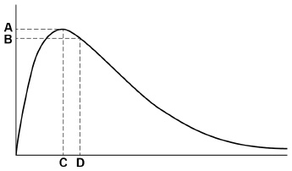
A B C D
Q2. Line X in the diagram represents the volume (V) of gas formed with time (t) in a reaction between an excess of magnesium and aqueous sulfuric acid.
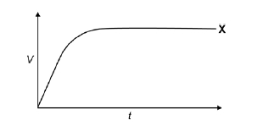
Which line represents the volume of hydrogen formed, at the same temperature and pressure, when the concentration of sulfuric acid has been halved?
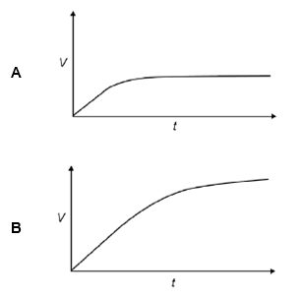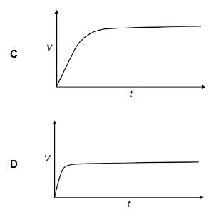
Q3. The question below is about the Maxwell–Boltzmann distribution shown for a sample of a gas, X, at two different temperatures.
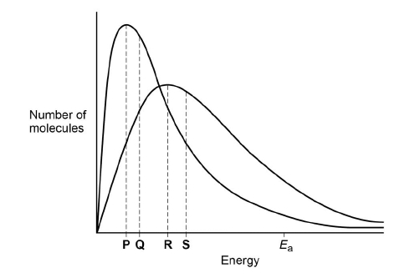
Which statement is correct for the higher temperature?

A | The area under the curve to the left of E_{a} decreases.
B | The total area under the curve increases.
C | The activation energy decreases.
D | More molecules have the mean energy.
Q4. This question is about the Maxwell–Boltzmann distribution of molecular energies in a sample of a gas shown in the following figure.
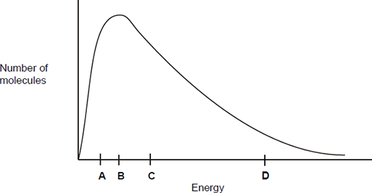
What does the area under the curve represent?

A | The total energy of the particles.
B | The total number of particles.
C | The number of particles that can react with each other.
D | The total number of particles that have activation energy.
Q5. The apparatus in the figure below was set up to measure the time taken for 20.0 cm³ of sodium thiosulfate solution to react with 5.0 cm³ of hydrochloric acid in a 100 cm³ conical flask at 20 °C. The timer was started when the sodium thiosulfate solution was added to the acid in the flask. The timer was stopped when it was no longer possible to see the cross on the paper.
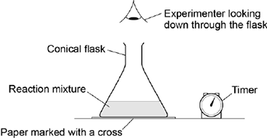
What is likely to decrease the accuracy of the experiment?
A | Rinsing the flask with acid before each new experiment.
B | Stirring the solution throughout each experiment.
C | Using the same piece of paper for each experiment.
D | Using different measuring cylinders to measure the volumes of acid and sodium thiosulfate.
Q6. The diagram below shows the Maxwell–Boltzmann energy distribution curve for a sample of gas at a fixed temperature. E_{a} is the activation energy for the decomposition of this gas.
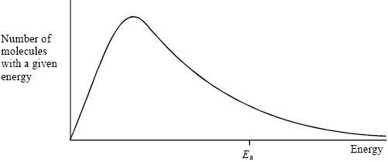
(a) On this diagram sketch the distribution curve for the same sample of gas at a higher temperature.
(3)
(b) (i) What is the effect of an increase in temperature on the rate of a chemical reaction?
Explain your answer with reference to the Maxwell–Boltzmann distribution.
Effect ________________________________________________________
Explanation ____________________________________________________
______________________________________________________________
______________________________________________________________
(ii) What is the effect of the addition of a catalyst on the rate of a chemical reaction?
Explain your answer with reference to the Maxwell–Boltzmann distribution.
Effect ________________________________________________________
Explanation ____________________________________________________
______________________________________________________________
______________________________________________________________(6)
(Total 9 marks)
Q7. (a) Figure 1 shows the volume of hydrogen gas collected when a sample of magnesium reacted with an excess of dilute hydrochloric acid.
The rate of this reaction can be studied by measuring the time it takes for a given volume of hydrogen to be collected.
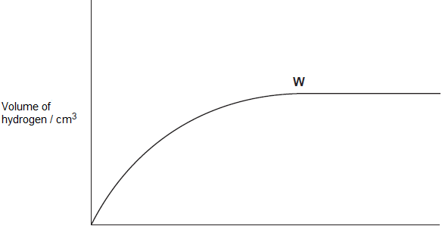
Time / s
(i) State the meaning of the term rate of reaction.
______________________________________________________________
______________________________________________________________
______________________________________________________________(1)
(ii) State and explain what has happened to the rate of this reaction at point W in Figure 1.
______________________________________________________________
______________________________________________________________
______________________________________________________________
______________________________________________________________(2)

(iii) In terms of collision theory explain why, at a fixed temperature, the rate of this reaction doubles when the concentration of the hydrochloric acid doubles.
______________________________________________________________
______________________________________________________________
______________________________________________________________
______________________________________________________________
______________________________________________________________
______________________________________________________________(2)
(b) In a study of the reaction in part (a), a student referred to activation energy.
(i) State the meaning of the term activation energy.
______________________________________________________________
______________________________________________________________(1)
(ii) Complete Figure 2 by drawing the shape of the reaction profile from reactants to products for an exothermic reaction.
Show the position of the products. Show and label the activation energy.
Figure 2
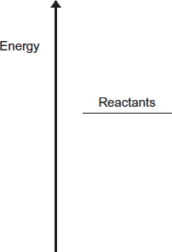
(2)
(c) Barium metal reacts very quickly with dilute hydrochloric acid, but it reacts more slowly with water.
(i) Write an equation for the reaction of barium with water.
______________________________________________________________(1)
(ii) A solution containing barium ions can be used to show the presence of sulfate ions in an aqueous solution of sodium sulfate.
Write the simplest ionic equation for the reaction that occurs and state what is observed.
Simplest ionic equation
______________________________________________________________
Observation
______________________________________________________________(2)
(iii) State one use of barium sulfate in medicine.
Explain why this use is possible, given that solutions containing barium ions are poisonous.
Use __________________________________________________________
______________________________________________________________
Explanation ____________________________________________________
______________________________________________________________
______________________________________________________________(2)
(Total 13 marks)
Q8. (a) Define the term activation energy for a chemical reaction.
___________________________________________________________________
___________________________________________________________________
___________________________________________________________________
___________________________________________________________________(2)
(b) Draw, with labelled axes, a curve to represent the Maxwell–Boltzmann distribution of molecular energies in a gas. Label this curve T₁. On the same axes, draw a second curve to represent the same sample of gas at a lower temperature. Label this curve T₂.
Use these curves to explain why a small decrease in temperature can lead to a large decrease in the rate of a reaction.
___________________________________________________________________
___________________________________________________________________
___________________________________________________________________
___________________________________________________________________
___________________________________________________________________
___________________________________________________________________
___________________________________________________________________
___________________________________________________________________
___________________________________________________________________
___________________________________________________________________
___________________________________________________________________
___________________________________________________________________
___________________________________________________________________
___________________________________________________________________
___________________________________________________________________
___________________________________________________________________
(8)
(c) Give one reason why most collisions between gas-phase reactants do not lead to a reaction. State and explain two ways of speeding up a gas-phase reaction other than by changing the temperature.
___________________________________________________________________
___________________________________________________________________
___________________________________________________________________
___________________________________________________________________
___________________________________________________________________
___________________________________________________________________
___________________________________________________________________
___________________________________________________________________
___________________________________________________________________
___________________________________________________________________
(5)
(Total 15 marks)
Q9. A method of synthesising ammonia directly from nitrogen and hydrogen was developed by Fritz Haber. On an industrial scale, this synthesis requires a high temperature, a high pressure and a catalyst and is very expensive to operate.
(a) Use the data given below to calculate a value for the enthalpy of formation of ammonia

Bond | N ≡N | H – H | N – H
Mean bond enthalpy/kJ mol^{–1} | 945 | 436 | 391
___________________________________________________________________
___________________________________________________________________
___________________________________________________________________
___________________________________________________________________
___________________________________________________________________
___________________________________________________________________(3)
(b) A manager in charge of ammonia production wished to increase the daily production of ammonia and reduce the production costs. How would a chemist explain the factors that would influence the commercial efficiency of this production process?
___________________________________________________________________
___________________________________________________________________
___________________________________________________________________
___________________________________________________________________
___________________________________________________________________
___________________________________________________________________
___________________________________________________________________
___________________________________________________________________
___________________________________________________________________
___________________________________________________________________
___________________________________________________________________
___________________________________________________________________
___________________________________________________________________
___________________________________________________________________
___________________________________________________________________
_________________________________________________________(8)(Total 11 marks)
Q10. When an aqueous solution of ethanoic acid reacts with magnesium, the progress of reaction can be followed using the equipment shown in Figure 1 to measure the volume of hydrogen produced.
Figure 1
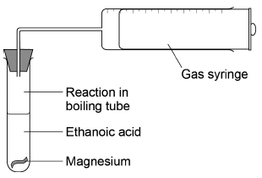
Figure 2 shows how the volume of hydrogen produced varies with time when 396 mg of magnesium are added to 30.0 cm³ of 0.600 mol dm⁻³ ethanoic acid.
Figure 2
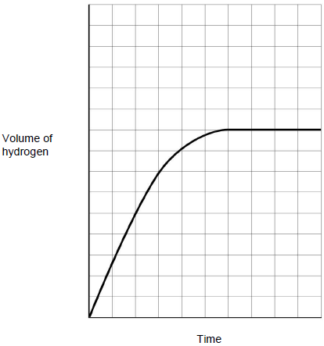
(a) The equation for the reaction between ethanoic acid and magnesium is shown.
2CH₃COOH(aq) + Mg(s) → (CH₃COO)₂Mg(aq) + H₂(g)

With the aid of calculations, show that the magnesium is in excess in this reaction.
___________________________________________________________________
___________________________________________________________________
___________________________________________________________________
___________________________________________________________________
___________________________________________________________________
___________________________________________________________________
___________________________________________________________________
___________________________________________________________________(3)
(b) The reaction was repeated using 20 cm³ of 0.800 mol dm⁻³ of ethanoic acid solution with all other conditions the same. The magnesium was still in excess.
Sketch a line on Figure 2 to show how the volume of hydrogen produced varies with time in this second experiment.
Space for working.

(2)
(Total 5 marks)

Mark schemes
Q1.D Q2.A Q3.A Q4.B Q5.A
Q6. (a) Peak lower
1
and moved to right
1
start at the origin and curve crosses once only
1
(b) (i) (Rate of reaction) increases
1
(At a higher temperature) more molecules/particles
1
have the minimum energy needed to react/have activation
energy/have successful collisions
Mark CE if incorrect effect given
1
(ii) (Rate of reaction) increases 1
lowers activation energy 1
so that more molecules are able to react 1
Mark CE if incorrect effect given
[9]
Q7. (a) (i) Change in concentration (of a substance / reactant / product) in unit time / given time / per (specified) unit of time
This may be written mathematically OR may refer to the gradient of a graph of concentration / volume against time
OR
Amount of substance formed / used up in unit time / given time / per (specified) unit of time
Ignore additional information including reference to collisions
1
(ii) At W
M1 (QoL)
The rate / it is zero
M2
The magnesium has all reacted / has been used up
Ignore reference to the acid being used up
OR
No more collisions possible between acid and Mg
OR
Reaction is complete / it has stopped
OR
No more hydrogen / product is produced
2
(iii) M1
Twice / double as many particles / hydrogen ions (in a given volume)
Penalise reference to (hydrochloric acid) molecules in M1
Penalise reference to “HCl particles” in M1
OR
Twice / double as much hydrochloric acid
M2
Twice / double as many effective / successful collisions (in a given time)
OR
Twice / double as many collisions with either sufficient energy to react OR with E ≥ E_{a}
OR
double the successful / effective collision frequency
2
(b) (i) The activation energy is the minimum energy for a reaction to go / start
OR
Minimum energy for a successful/ effective collision
1
(ii) M1 Products lower than reactants on the profile
Mark independently
M2 Activation energy (E_{a}) shown and labelled correctly from reactants to peak of curve
Mark independently
2
(c) (i) Ba + 2H₂O Ba(OH)₂ + H₂
Ba + 2H₂O Ba²⁺ + 2OH⁻ + H₂
Allow multiples
Ignore state symbols
1
(ii) M1 Ba²⁺ + SO₄²⁻ BaSO₄
Ignore state symbols in M1
Not multiples in M1
M2 White precipitate / solid
Extra ions must be cancelled
Penalise contradictory observations in M2
2
(iii) M1 Barium meal / barium swallow / barium enema
Accept a correct reference to M1 written in the explanation in M2, unless contradictory
OR used in X-rays OR to block X-rays OR X-ray contrast medium OR CT scans
M2 BaSO₄ / barium sulfate is insoluble (and therefore not toxic)
For M2 NOT barium ions
NOT barium
NOT barium meal and NOT “It”
Ignore radio-tracing
2
[13]
Q8.(a) the minimum energy;
1
Energy required for a reaction to occur;
(or to start a reaction or for successful collisions)
1
(b) axes labelled:- y: number (or fraction or %) of molecules (or particles)
x: energy (or KE);
1
curve starts at origin;
1
skewed to right;
1
approaches x axis as an asymptote;
(penalise a curve that levels off > 10% of max peak height or a curve that crosses the energy axis)
1
second curve displaced to the left (and does not cross T₁ curve
for a second time)
1
and peak higher;
1
many fewer molecules;
1
fewer molecules have E > E_{a} ;
(can score this mark from suitably marked curves)
1
(c) molecules (or particles or collisions) do not have enough energy;
(or orientation may be wrong)
1
increase the pressure;
1
(or increase the concentration or reduce the volume)
increases the collision frequency;
(or more collisions)
(do not allow if stated to be due to increase in energy implied by temperature increase)
1
add a catalyst;
1
lowers activation energy (or E_{a}) (Q of L mark);
1
[15]
Q9. (a) Equation 1/2N₂ + 3/2H₂ → NH₃
1
ΔHf = [(945 × 0.5) + (426 × 1.5)] – (391 × 3)
1
= –46.5 kJ mol^{–1}
1

Mark  Range | The marking scheme for this part of the question includes an overall assessment for the Quality of Written Communication (QWC). There are no discrete marks for the assessment of QWC but the candidates’ QWC in this answer will be one of the criteria used to assign a level and award the marks for this part of the question  Descriptor  an answer will be expected to meet most of the criteria in the level descriptor
4-5 | – claims supported by an appropriate range of evidence  – good use of information or ideas about chemistry, going beyond those given in the question  – argument well structured with minimal repetition or irrelevant points  – accurate and clear expression of ideas with only minor errors of grammar, punctuation and spelling
2-3 | – claims partially supported by evidence  – good use of information or ideas about chemistry given in the question but limited beyond this  – the argument shows some attempt at structure  – the ideas are expressed with reasonable clarity but with a few errors of grammar, punctuation and spelling
0-1 | – valid points but not clearly linked to an argument structure  – limited use of information or ideas about chemistry  – unstructured  – errors in spelling, punctuation and grammar or lack of fluency
(b) The higher the temperature the faster the reaction QWC
1
but, since the reaction is exothermic
1
the equilibrium yield is lower QWC
1
The higher the pressure the greater the equilibrium yield QWC
1
because there is a reduction in the number of moles of gas
in the reaction
1
but higher pressure is expensive to produce or plant is more
expensive to build QWC
1
A better catalyst would lessen the time to reach equilibrium
1
and allow more ammonia to be produced in a given time QWC
1
[11]
Q10. (a) Method 1
Allow working throughout to 2sf
M1 Moles of Mg = 0.396/24.3 = 0.0163
1
M2 Moles of CH₃COOH = 0.600 × 30.0/1000 = 0.018
1
M3 Mark for showing Mg is in excess: either
0.018 mol of CH₃COOH reacts with 0.009 mol of Mg OR
0.0163 mol of Mg reacts with 0.0326 mol of CH₃COOH OR 0.0073 mol of Mg is in excess
1
If candidate gets 16.3 mol (as not converted mg to g) in method 1 or 3 then can only score 1 mark maximum (M2)
Accept other valid calculations that show the Mg is in excess
Method 2
M1 Moles of CH₃COOH = 0.600 × 30.0/1000 = 0.018
M2 Moles of Mg that would react with this = 0.009
M3 Mass of Mg needed = 24.3 × 0.009 = 0.219 g which is less than 0.396 g OR
Moles of Mg = 0.0163 which is more than 0.009 required
Method 3
M1 Moles of Mg = 0.396/24.3 = 0.0163
M2 Moles of CH₃COOH that would react with this = 0.0326
M3 Volume of CH₃COOH needed = 0.0326 / 0.60 = 0.0543 dm³ (54.3 cm³) which is more than 0.030 dm³ (30 cm³)
(b) M1 Line starts at origin and is steeper
1
M2 (moles CH₃COOH = 0.800 × 20/1000 = 0.016) line levels out on 8th line up (line below the original 9th line)
M2 for line on 8th line on grid (original on 9th line) – allow some leniency so long as clear it ends at (or very close to) the 8th line; and line does not significantly wobble
1
[5]

