Q1. How many different alkenes are formed when 2-bromo-2-methylbutane reacts with ethanolic potassium hydroxide?
A 2
B 3
C 4
D 5
Q2. Which one of the following statements explains best why fluoroalkanes are the least reactive haloalkanes?
A Fluorine is much more electronegative than carbon.
B The F⁻ ion is the most stable halide ion.
C The C–F bond is the most polar carbon–halogen bond.
D The C–F bond is the strongest carbon–halogen bond.
Q3. Pentanenitrile can be made by reaction of 1-bromobutane with potassium cyanide.
Which of these is the correct name for the mechanism of this reaction?

A | Electrophilic addition
B | Electrophilic substitution
C | Nucleophilic addition
D | Nucleophilic substitution
Q4. This question is about a method that can be used to prepare ethylamine.
CH₃CH₂Br + 2NH₃ CH₃CH₂NH₂ + NH₄Br
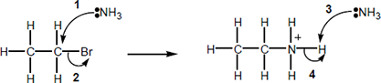
Which statement about the reaction is not correct?

A | Ethylamine is a primary amine.
B | The mechanism is a nucleophilic substitution.
C | Using an excess of bromoethane will prevent further reaction to form a mixture of amine products.
D | Ammonium bromide is an ionic compound.
Q5. Which of the arrows, labelled A, B, C or D in the mechanism in the diagram, is not correct?
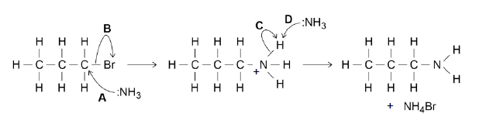
A
B
C
D
Q6. Compound A is a halogenoalkane.
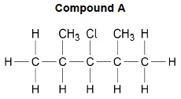
(a) Name Compound A.
___________________________________________________________________(1)
(b) Compound A has a relative molecular mass (Mr) of 134.5
The main isotope of hydrogen is ¹H
The main isotope of carbon is ¹²C
Chlorine consists of two common isotopes, ³⁵Cl and ³⁷Cl, of which 75% is ³⁵Cl
The mass spectrum of A was recorded when A was ionised by electron impact to form A⁺ ions.
Draw, on Figure 1, the peaks for the main molecular ions in the mass spectrum of A.
Figure 1
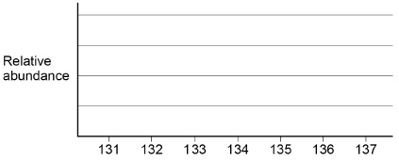
(2)
(c) Reaction of A with warm, dilute aqueous sodium hydroxide forms alcohol B.
Name the mechanism for this reaction.
Outline the mechanism using the structure of A shown.
Include the structure of the product, alcohol B.
Mechanism _________________________________________________________
Outline of mechanism
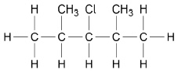
(4)
(d) Reaction of A with hot, ethanolic potassium hydroxide gives alkene C.
Name the mechanism for this reaction.
State the role of the hydroxide ions.
Outline the mechanism using the structure of A shown.
Include the structure of the product, alkene C.
Mechanism _________________________________________________________
Role of hydroxide ions ________________________________________________
Outline of mechanism
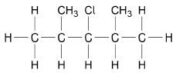
(6)
(e) The infrared spectrum in Figure 2 is that of either alcohol B or alkene C.
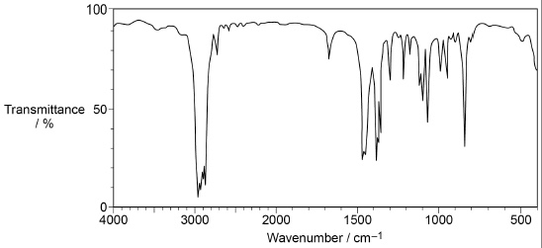
Tick the box that shows the correct compound.
Explain your answer with reference to a bond and the wavenumber of its absorption.

Alcohol B | 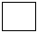 | Alkene C
Explanation _________________________________________________________
___________________________________________________________________
___________________________________________________________________(1)
(f) Compound D reacts with dilute aqueous sodium hydroxide in a similar way to A to form alcohol B.
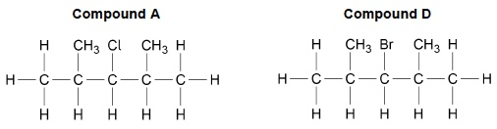
Explain why D reacts more quickly than A with dilute aqueous sodium hydroxide at the same temperature.
___________________________________________________________________
___________________________________________________________________
___________________________________________________________________
___________________________________________________________________
___________________________________________________________________(1)
(Total 15 marks)
Q7. 2-Methylpropan-1-ol can be prepared by reacting 1-bromo-2-methylpropane with dilute aqueous sodium hydroxide.
(a) Name and outline the mechanism for this reaction.
Name of mechanism __________________________________________________
Mechanism

(3)
(b) When 2.0 cm³ of 1-bromo-2-methylpropane (M_{r} = 136.9) were reacted with an excess of sodium hydroxide, 895 mg of 2-methylpropan-1-ol (Mr = 74.0) were obtained.
The density of 1-bromo-2-methylpropane is 1.26 g cm⁻³
Calculate the percentage yield for this reaction.
Percentage yield _________________________________________

(3)
(c) When 1-bromo-2-methylpropane reacts with hot, concentrated ethanolic potassium hydroxide rather than dilute aqueous sodium hydroxide, a different product is formed.
Name this organic product and name the mechanism for this reaction.
Name of organic product _______________________________________________
Name of mechanism __________________________________________________(2)
(Total 8 marks)
Q8. CCl₄ is an effective fire extinguisher but it is no longer used because of its toxicity and its role in the depletion of the ozone layer. In the upper atmosphere, a bond in CCl₄ breaks and reactive species are formed.
(a) Identify the condition that causes a bond in CCl₄ to break in the upper atmosphere.
Deduce an equation for the formation of the reactive species.
Condition ___________________________________________________________
Equation
___________________________________________________________________(2)
(b) One of the reactive species formed from CCl₄ acts as a catalyst in the decomposition of ozone. Write two equations to show how this species acts as a catalyst.
Equation 1
___________________________________________________________________
Equation 2
___________________________________________________________________(2)
(c) A small amount of the freon CF₃Cl with a mass of 1.78 × 10^{–4} kg escaped from a refrigerator, into a room of volume 100 m³. Assuming that the freon is evenly distributed throughout the air in the room, calculate the number of freon molecules in a volume of 500 cm³.
Give your answer to the appropriate number of significant figures.
The Avogadro constant = 6.02 × 10²³ mol⁻¹.

Number of molecules = __________ (3) (Total 7 marks)
Q9. Two reactions of 2-bromopentane, (CH₃CH₂CH₂CHBrCH₃) are shown.
The C₅H₁₀ formed in reaction 1 exists as a mixture of three isomers, one of which is pent-1-ene. Two of the isomers are a pair of stereoisomers. All three isomers decolourise bromine.
(a) The same reagent is used in both reactions. The product is determined by the choice of conditions.
State the reagent and the conditions for each of reaction 1 and reaction 2.
State the role of the reagent in each reaction.
Name and outline the mechanism of reaction 1 for the formation of pent-1-ene.
___________________________________________________________________
___________________________________________________________________
___________________________________________________________________
___________________________________________________________________
___________________________________________________________________
___________________________________________________________________
(8)

(b) All three isomers of C₅H₁₀ contain the same functional group.
Draw the displayed formula of pent-1-ene.
Draw the structures of the pair of stereoisomers and give their full IUPAC names.
Explain the origin of the stereoisomerism shown.
___________________________________________________________________
___________________________________________________________________
___________________________________________________________________
___________________________________________________________________
___________________________________________________________________(5)
(c) The rates of hydrolysis of two chloroalkanes can be investigated by adding aqueous silver nitrate to the chloroalkanes. During the hydrolysis reactions, chloride ions are liberated slowly. Precipitates of silver chloride are formed.
Outline a method to compare the rate of hydrolysis of 1-chlorobutane with that of 2-chlorobutane. State how the method would ensure a fair test.
___________________________________________________________________
___________________________________________________________________
___________________________________________________________________
___________________________________________________________________
___________________________________________________________________
___________________________________________________________________
___________________________________________________________________
___________________________________________________________________
_________________________________________________________(4)(Total 17 marks)

Mark schemes
Q1. A Q2.D Q3.D Q4.C Q5.C
Q6.
(a) 3-chloro-2,4-dimethylpentane
This answer only apart from slips with commas and dashes
1
(b) M1 lines at 134 and 136
M1 is for drawing the correct two lines (if other lines are drawn, penalise M1 (but ignore any additional very small lines at 135 or 137)
1
M2 line at 134 to be three times higher than line at 136
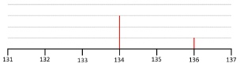
M2 is for the line at 134 being three times as big as the one at 136 (ignore other lines)
Accept cross to represent top of lines; if bars drawn – they should be narrow (less than 10% of division) and clear which value they refer to.
1
(c) M1 nucleophilic substitution
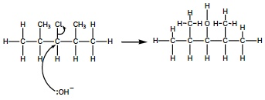
1
M2 curly arrow from lone pair on O of OH– to C of C–Cl
For SN2: penalise M2 for any additional arrow(s) on NaOH, or for covalent NaOH; penalise M3 for any additional arrow(s) to/from the Cl to/from anything else
If curly arrows represent an attempt at an elimination mechanism, cannot score M2 or M3
1
M3 curly arrow from C–Cl bond to the Cl
Penalise M3 for formal charge on C and/or Cl of C–Cl or incorrect partial charges on C– Cl; ignore other partial charges on uncharged atoms
For SN2: penalise M2 for any additional arrow(s) on NaOH, or for covalent NaOH; penalise M3 for any additional arrow(s) to/from the Cl to/from anything else
If curly arrows represent an attempt at an elimination mechanism, cannot score M2 or M3
If SN1 mechanism given (loss of Cl first followed by attack by OH–) then:
M2 curly arrow from C–Cl bond to the Cl
M3 curly arrow from lone pair on O of OH– to positive C atom of correct carbocation
penalise M2 for any additional arrow(s) to/from the Cl to/from anything else
penalise M3 for any additional arrow(s) on NaOH
1
M4 correct structure of alcohol (in any form)
M4 is independent
M4 ignore presence of non-organic products
1
(d) M1 elimination
M1 allow base elimination (but nothing else)
1
M2 base
M2 allow proton acceptor
1
M3 curly arrow from lone pair on O of OH– to H on one of the C atoms adjacent to the C–Cl
If curly arrows represent an attempt at a substitution mechanism, cannot score M3 or M4
1
M4 curly arrow from a correct C-H bond adjacent to the C–Cl to a correct C-C bond. Only award if an arrow is shown attacking the H atom of a correct adjacent C-H bond in M3
If curly arrows represent an attempt at a substitution mechanism, cannot score M3 or M4
1
M5 curly arrow from C–Cl bond to the Cl (mark is independent
Penalise M5 for formal charge on C and/or Cl of C–Cl or incorrect partial charges on C–Cl; ignore other partial charges on uncharged atoms
1
M6 correct structure of alkene (in any form)
M6 is independent
M6 ignore presence of non-organic products
If E1 mechanism given (loss of Cl first followed by attack by OH–) then:
M3 curly arrow from C–Cl bond to the Cl
M4 curly arrow from lone pair of OH– to a correct H on the correct C adjacent to C⁺ on the carbocation
M5 curly arrow from a correct C-H bond to a correct C-C bond
penalise M3 for any additional arrow(s) to/from the Cl to/from anything else
penalise M4 for any additional arrow(s) on KOH
1
(e) C as C=C 1620-1680 cm^{–1} OR no O-H 3230-3550 cm^{–1}
need the correct compound and an explanation
full wavenumber range or value(s) within the range
on this occasion candidates do not need to refer to the O-H bond being O-H alcohol as opposed to O-H acid – just reference to O-H with wavenumbers is required
1
(f) C–Br is weaker than C–Cl or
C–Br has lower bond enthalpy than C–Cl or
C–Br breaks more easily C–Cl
Must compare the C–Br and C–Cl bonds specifically
Ignore references to bond length, size of atoms, shielding, electronegativity and polarity
Penalise idea that bromine is more reactive than chlorine
1
[15]
Q7.(a) M1 nucleophilic substitution
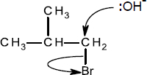
Penalise M3 for formal charge on C and/or Br of C‑Br or incorrect partial charges on C‑Br
Max 1 out of 2 for M2 & M3 for incorrect reactant or product (ignore poorly drawn bond from C to OH group in product if shown)
For SN²
penalise M2 for any additional arrow(s) on NaOH
penalise M3 for any additional arrow(s) to/from the Br to/from anything else
1
M2 curly arrow from lone pair on O of OH⁻ to C of C‑Br
1
M3 curly arrow from C‑Br bond to the Br
1
If SN¹ mechanism given (loss of Br first followed by attack by OH⁻) then:
M2 curly arrow from C-Br bond to the Br
M3 curly arrow from lone pair on O of OH⁻ to positive C atom of correct carbocation
penalise M2 for any additional arrow(s) to/from the Br to/from anything else
penalise M3 for any additional arrow(s) on NaOH
If curly arrows represent an attempt at an elimination mechanism, cannot score M2 or M3
(b) M1 Amount 1-bromo-2-methylpropane
(= (2 × 1.26) / 136.9 = 2.52/136.9) = 0.0184 mol
Correct answer scores 3 marks; answer to at least 2sf and any individual marks for M1/2 should be at least 2sf; answers that are a factor of 10^{x} out score 2;
1
M2 mass of 2-methylpropan-1-ol expected
(= 0.0184 × 74.0) = 1.36 g
Allow ECF through the question
1
M3 % yield = 100 × (0.895/1.36) = 65.7% (65-67%)
1
Alternative method:
M2 amount of 2-methylpropan-1-ol produced
= 0.895/74.0 = 0.0121 mol
M3 % yield = 100 × (0.0121/0.0184) = 65.7% (65‑67%)
Allow 2 marks for 82.7‑83% (comes from starting with 2 g not 2.52 g), with answers that are a factor of 10^{x} out from this scoring 1
(c) M1 methylpropene
M1 Do not allow any names with numbers for the position of the double bond. Allow 2-methylpropene but no other answer
Ignore any drawn mechanism
1
M2 elimination
M2 allow base (or basic) elimination but no other answer
1 [8]
Q8.(a) UV light
1
CCl₄ CCl₃• + •Cl
1
(b) Cl• + O₃ ClO• + O₂
1
ClO• + O₃ Cl• + 2O₂
1
(c) M_{r} of CF₃Cl = 104.5
Moles freon = 1.78 × 10^{–4} × 10³ / 104.5 = 1.70 × 10^{–3}
1
Number of molecules = 1.70 × 10^{–3} × 6.02 × 10²³ = 1.02 × 10²¹
1
Molecules in 500 cm³ = (1.02 × 10²¹ × 500 × 10^{–6}) / 100
= 5.10 × 10¹⁵
Allow answer in the range 5.10–5.13 × 10¹⁵
Answer must be given to this precision
1[7]
Q9.(a) NaOH/KOH
IGNORE OH-
NOT M1 if any mention of acidified/H+ in reagents or conditions
1
Reaction 1 = ethanolic/alcoholic AND reaction 2 = aqueous
IGNORE temp
NOT ethanoic
1
rxn 1 = base/proton acceptor
1
rxn 2 = nucleophile/lone pair donor/electron pair donor
1
(Base) Elimination
NOT nucleophilic
1
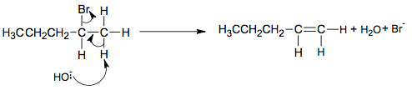
M6 must show an arrow from the lone pair on the oxygen of a negatively charged hydroxide ion to a correct H atom
M7 must show an arrow from a correct C–H bond on C adjacent to the C of the C–Br bond to a correct C–C bond. Only award if an arrow is shown attacking the H atom of a correct adjacent C–H bond in M6
M8 is independent provided it is from their original molecule and shows curly arrow from C-Br to Br
ALLOW correct E1 mechanism
IGNORE incorrect inorganic products
If forming pent-2-ene can award M8 only even if arrows in mechanism correct
If C chain length or halogen wrong in reactant or product max 2/3
1
1
1
(b) 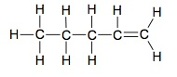
1
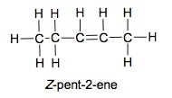
1
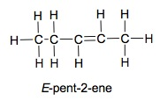
1
If no M2 and M3 ALLOW 1 mark if both structures OR both names correct
NOT cis and trans
No free rotation around C=C
ALLOW no rotation of C=C
1
2 different atoms/groups on each of the C=C Cs owtte
IGNORE ‘functional’
1
(c) Same volume/amount of AgNO₃(aq) added to same volume/amount/no. of drops of haloalkane (in beaker/flask) in each experiment
Both volume references needed
IGNORE inappropriate volumes
1
Same temp OR same [AgNO₃] each time
1
record time to measure sensible observation about the amount of AgCl ppt
e.g. first appearance of ppt / ppt obscures mark / reading on a colorimeter
IGNORE colour of ppt
ALLOW silver mirror
NOT reference to same time if describing method based on timing how long (for ppt to form)
ALLOW gravimetric method based on same time for each experiment 1
Rate = amount/time OR proportional to 1/time OR reference to shorter time = higher rate/longer time = lower rate
ALLOW greater mass = higher rate if gravimetric method 1 [17]

