Sentence | Picture | Word Equation | Equation
Feeding My Alligator | 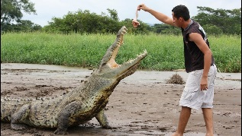 | Force = Mass x Acceleration | F = m x a
Weeding My Garden |  | Weight = Mass x Gravitational Field Strength | W = m x g
Queue In Tesco |  | Charge = Current x Time | Q = I x t
My Violent Donkey |  | Mass = Volume x Density | M = V x D
Feeding Kenny’s Elephant |  | Force = Spring Constant x Extension | F = k x e
Wendy Died Feeding Dinosaur | 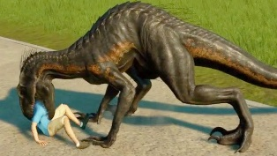 | Work Done = Force x Distance | WD = F x D
Man Feeding Dinosaur | 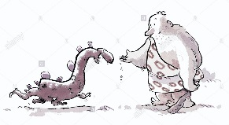 | Moment = Force x Distance | M = F x D
Five Picnicking Anteaters |  | Force = Pressure x Area | F = P x A
Vampires Increase Rabies |  | Potential = Current x Resistance  Difference | V = I x R
Parrot In Van | 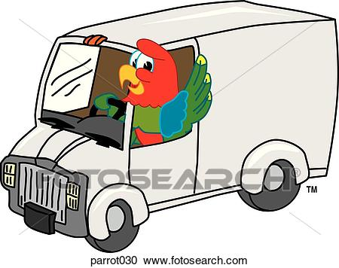 | Power = Current x Potential Difference | P = I x V
Parrot In Ice Rink |  | Power = Current² x Resistance | P = I²R
Every Parrot Talks | 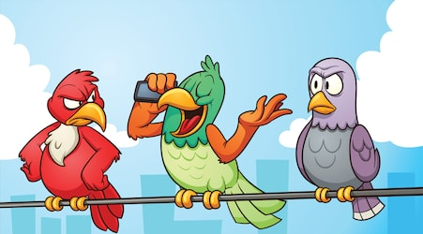 | Energy = Power x Time | E = P x t
Eat Quietly Victoria! |  | Energy = Charge x Potential Difference | E = Q x V
Every Monday Go Home |  | Gravitational Potential Energy =  Mass x Gravitational Field Strength x Height | E_{p} = m x g x h
Kenny Eats Half Mangoes Very Vigorously |  | Kinetic = ½ x mass x velocity²  Energy | E_{k} = ½ x m x v²
Don’t Splash, Toby! |  | Distance = Speed x Time | D = s x t
Wendy Died Playing Tennis | 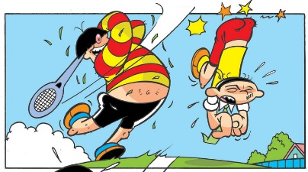 | Work Done = Power x Time | WD = P x t

The equations for Wave Speed, Efficiency and Acceleration are not included here.
How do I remember the equation?
- Think of the sentence eg Parrot In Van
- Write down the initial letters eg PIV
- Put an “=” between the first letters and a “x” between the last 2 eg P = I x V
This will work for most and will be the correct answer to any recall question at GCSE. For the ones with a squared, if the letter is the same, that value is squared eg Parrot In Ice Rink is P = I x I x R which is P = I² x R.
I have tried to make the pictures a bit silly as that helps students to remember.

