Q1. Quantities in physics are either scalars or vectors.
(a) Use the correct answers from the box to complete the sentence.

acceleration | direction | distance | speed | time
Velocity is __________________________ in a given ________________ . (2)
(b) Complete the table to show which quantities are scalars and which quantities are vectors.
Put one tick () in each row.
The first row has been completed for you.

Quantity | Scalar | Vector
Momentum
Acceleration
Distance
Force
Time
(3)
(c) The diagram shows two supermarket trolleys moving in the same direction.
Trolley A is full of shopping, has a total mass of 8 kg and is moving at a velocity of 2 m / s with a kinetic energy of 16 J.
Trolley B is empty, has a mass of 4 kg and is moving at a velocity of 0.5 m / s with a kinetic energy of 0.5 J.
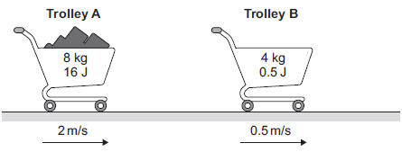
(i) Calculate the momentum of both trolley A and trolley B.
Give the unit.
______________________________________________________________
______________________________________________________________
Momentum of trolley A = _______________
Momentum of trolley B = _______________ Unit __________ (4)
(ii) The trolleys in the diagram collide and join together. They move off together.
Calculate the velocity with which they move off together.
______________________________________________________________
______________________________________________________________
______________________________________________________________
______________________________________________________________
Velocity = _______________ m / s (3)
(iii) In a different situation, the trolleys in the diagram move at the same speeds as before but now move towards each other.
Calculate the total momentum and the total kinetic energy of the two trolleys before they collide.
______________________________________________________
______________________________________________________________
Total momentum = _________________
______________________________________________________________
______________________________________________________________
Total kinetic energy = _______________ J (2)(Total 14 marks)

Q2. A driver is driving along a road at 30 m/s. The driver suddenly sees a large truck parked across the road and reacts to the situation by applying the brakes so that a constant braking force stops the car. The reaction time of the driver is 0.67 seconds, it then takes another 5 seconds for the brakes to bring the car to rest.
(a) Using the data above, draw a speed-time graph to show the speed of the car from the instant the truck was seen by the driver until the car stopped.
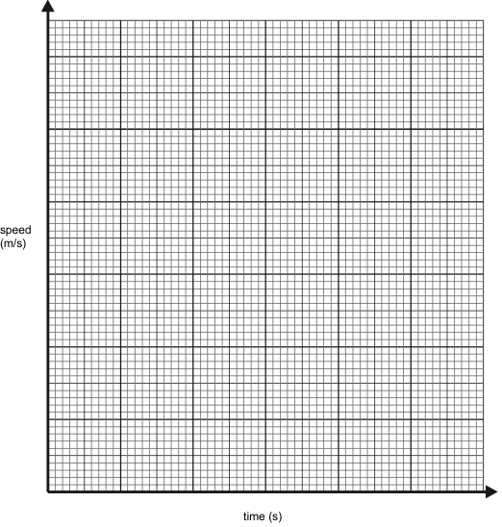(5)
(b) Calculate the acceleration of the car whilst the brakes are applied.
___________________________________________________________________
___________________________________________________________________
___________________________________________________________________
Answer = __________________ m/s² (3)
(c) The mass of the car is 1500 kg. Calculate the braking force applied to the car.
___________________________________________________________________
___________________________________________________________________
___________________________________________________________________
Answer = __________________ N (3)
(d) The diagrams below show what would happen to a driver in a car crash.
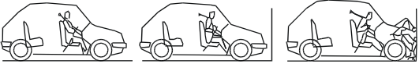
(i) Explain why the driver tends to be thrown towards the windscreen.
______________________________________________________________
______________________________________________________________
______________________________________________________________
______________________________________________________________
______________________________________________________________
______________________________________________________________
(ii) The car was travelling at 30 m/s immediately before the crash. Calculate the energy which has to be dissipated as the front of the car crumples.
______________________________________________________________
______________________________________________________________
______________________________________________________________
____________________________________________________(8)(Total 17 marks)
Q3. (a) The diagram shows a microphone being used to detect the output from a loudspeaker.
The oscilloscope trace shows the wave pattern produced by the loudspeaker.
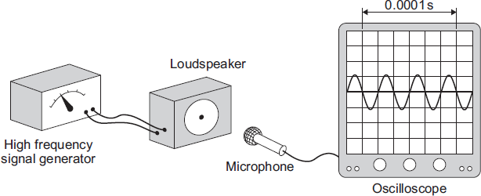
(i) How many waves are produced by the loudspeaker in 0.0001 seconds?
____________________________________________________________(1)
(ii) How many waves are produced by the loudspeaker every second?
Assume the input to the loudspeaker does not change.
______________________________________________________________
______________________________________________________________(1)
(iii) A person with normal hearing cannot hear the sound produced by the loudspeaker.
Explain why.
______________________________________________________________
______________________________________________________________
______________________________________________________________(2)
(b) The diagram shows how a very high frequency sound wave can be used to check for internal cracks in a large steel bolt. The oscilloscope trace shows that the bolt does have an internal crack.
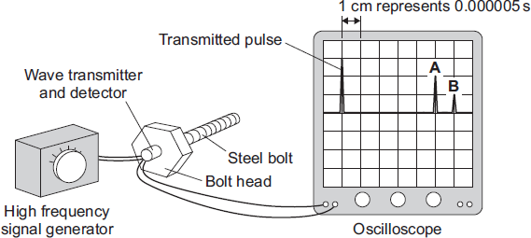
(i) Explain what happens to produce pulse A and pulse B.
______________________________________________________________
______________________________________________________________
______________________________________________________________
______________________________________________________________(2)
(ii) Use the information in the diagram and the equation in the box to calculate the distance from the head of the bolt to the internal crack.

distance = speed × time
Speed of sound through steel = 6000 m/s
Show clearly how you work out your answer.
______________________________________________________________
______________________________________________________________
______________________________________________________________
______________________________________________________________
_____________________________________________________(3)(Total 9 marks)
Q4. Different parts of the electromagnetic spectrum have different uses.
(a) The diagram shows the electromagnetic spectrum.

Radio waves | Microwaves | Infrared | Visible light | Ultraviolet | X-rays | Gamma rays
(i) Use the correct answers from the box to complete the sentence.

amplitude | frequency | speed | wavelength
The arrow in the diagram is in the direction of increasing _____________
and decreasing ____________ . (2)
(ii) Draw a ring around the correct answer to complete the sentence.
The range of wavelengths for waves in the electromagnetic

spectrum is approximately | 10⁻¹⁵ to 10⁴  10⁻⁴ to 10⁴  10⁴ to 10¹⁵ | metres.
(1)
(b) The wavelength of a radio wave is 1500 m.
The speed of radio waves is 3.0 × 10⁸ m / s.
Calculate the frequency of the radio wave.
Give the unit.
___________________________________________________________________
___________________________________________________________________
___________________________________________________________________
Frequency = ____________________(3)
(c) (i) State one hazard of exposure to infrared radiation.
______________________________________________________________(1)
(ii) State one hazard of exposure to ultraviolet radiation.
______________________________________________________________(1)
(d) X-rays are used in hospitals for computed tomography (CT) scans.
(i) State one other medical use for X-rays.
______________________________________________________________
______________________________________________________________ (1)
(ii) State a property of X-rays that makes them suitable for your answer in part (d)(i).
______________________________________________________________
______________________________________________________________ (1)
(iii) The scientific unit of measurement used to measure the dose received from radiations, such as X-rays or background radiation, is the millisievert (mSv).
The table shows the X-ray dose resulting from CT scans of various parts of the body.
The table also shows the time it would take to get the same dose from background radiation.

Part of the  body | X-ray dose  in mSv | Time it would take to get the same  dose from background radiation
Abdomen | 9.0 | 3 years
Sinuses | 0.5 | 2 months
Spine | 4.0 | 16 months
A student suggests that the X-ray dose and the time it would take to get the same dose from background radiation are directly proportional.
Use calculations to test this suggestion and state your conclusion.
______________________________________________________________
______________________________________________________________
______________________________________________________________
______________________________________________________________
______________________________________________________________
______________________________________________________________
______________________________________________________________
______________________________________________________________
______________________________________________________________
______________________________________________________________
(3)
(Total 13 marks)

Q5. Figure 1 shows what happens when a ray of light enters a tin can through a small hole.
Figure 1
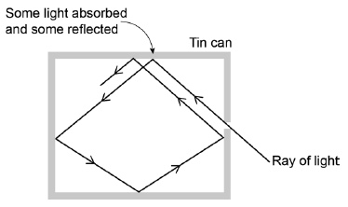
(a) Explain why the small hole looks black.
___________________________________________________________________
___________________________________________________________________
___________________________________________________________________
___________________________________________________________________
___________________________________________________________________(2)
(b) All objects absorb and emit radiation.
What is meant when an object is described as a perfect black body?
___________________________________________________________________
___________________________________________________________________(1)

Figure 2 shows how the intensity of different wavelengths of radiation from a hot object varies with temperature.
Figure 2
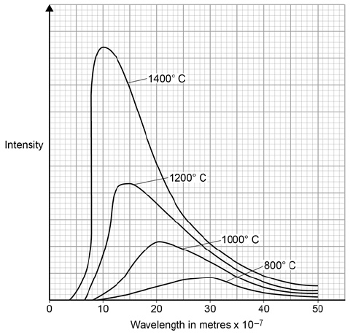
(c) What can be concluded from Figure 2 about how the distribution of the intensity of radiation from an object changes as the temperature of the object increases?
___________________________________________________________________
___________________________________________________________________
___________________________________________________________________
___________________________________________________________________
___________________________________________________________________
___________________________________________________________________
___________________________________________________________________
___________________________________________________________________
___________________________________________________________________(3)
(d) The wavelength at which the Sun emits the maximum intensity of radiation is approximately 5 × 10–7 m
Estimate the surface temperature of the Sun.
Use Figure 2.
___________________________________________________________________(1)
(e) Figure 3 shows how the balance between the incident radiation from space and the radiation emitted by the Earth into space has changed over the last 200 years.
Figure 3
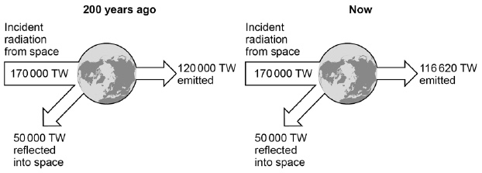
Explain how the temperature of the Earth and its atmosphere has changed over the last 200 years.
Use the information in Figure 3.
___________________________________________________________________
___________________________________________________________________
___________________________________________________________________
___________________________________________________________________
___________________________________________________________________
___________________________________________________________________
___________________________________________________________________
___________________________________________________________________
___________________________________________________________________
(3)
(Total 10 marks)

Q6. (a) A light bulb is placed between a convex lens and the principle focus of this lens, at position N shown in Figure 1. The light bulb is then moved to position M, a large distance from the lens.
Figure 1
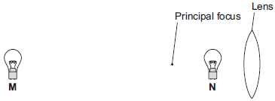
Describe how the nature of the image formed changes as the light bulb is moved from position N to position M.
___________________________________________________________________
___________________________________________________________________
___________________________________________________________________
___________________________________________________________________
___________________________________________________________________(3)
(b) An object, O, is very near to a convex lens, as shown in Figure 2.
Complete Figure 2 to show how rays of light from the object form an image.
Figure 2
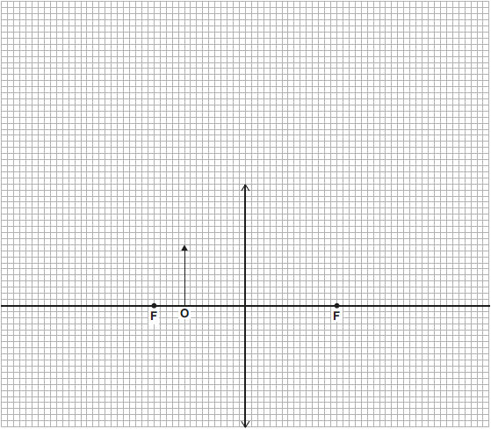
(3)
(c) The object distance is the distance from an object to the lens. The image distance is the distance from the lens to the image.
Figure 3 shows how the image distance changes with the object distance, for two identically shaped convex lenses, A and B. Each lens is made from a different type of glass.
Figure 3
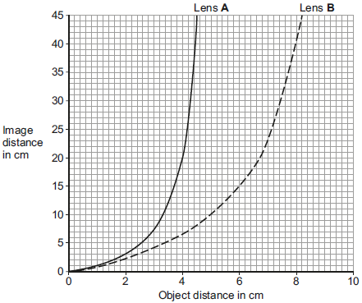
(i) When the object distance is 4 cm, the image distance for lens A is longer than for lens B.
State why.
______________________________________________________________
______________________________________________________________(1)
(ii) When the object is moved between lens B and the principal focus, the image size changes. The table shows the magnification produced by lens B for different object distances.

Object distance in cm | Magnification
0.0 | 1
5.0 | 2
6.7 | 3
7.5 | 4
8.0 | 5
Using information from Figure 3 and the table, describe the relationship between the image distance and the magnification produced by lens B.
______________________________________________________________
______________________________________________________________(2)
(iii) A third convex lens, lens C, is made from the same type of glass as lens B, but has a shorter focal length than lens B.
Lens B is shown in Figure 4.
Complete Figure 4 to show how lens C is different from lens B.
Figure 4
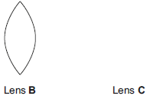 (1) (Total 10 marks)
Q7.Forces have different effects.
(a) (i) Use the correct answer from the box to complete the sentence.

slowing | stretching | turning
The moment of a force is the ________________________________ effect of the force. (1)
(ii) What is meant by the centre of mass of an object?
______________________________________________________________
______________________________________________________________(1)
(b) Some children build a see-saw using a plank of wood and a pivot.
The centre of mass of the plank is above the pivot.
Figure 1 shows a boy sitting on the see-saw. His weight is 400 N.
Figure 1
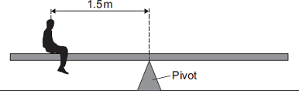

Calculate the anticlockwise moment of the boy in Nm.
___________________________________________________________________
___________________________________________________________________
Anticlockwise moment = ____________________ Nm
(2)
(c) Figure 2 shows a girl sitting at the opposite end of the see-saw. Her weight is 300 N.
Figure 2
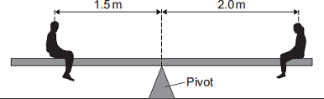
The see-saw is now balanced.
The children move the plank. Its centre of mass, M, is now 0.25 m from the pivot as shown in Figure 3.
Figure 3
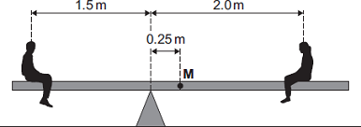
The boy and girl sit on the see-saw as shown in Figure 3.
(i) Describe and explain the rotation of the see-saw.
______________________________________________________________
______________________________________________________________
______________________________________________________________
______________________________________________________________
______________________________________________________________
______________________________________________________________
______________________________________________________________(3)
(ii) The boy gets off the see-saw and a bigger boy gets on it in the same place. The girl stays in the position shown in Figure 3. The plank is balanced. The weight of the plank is 270 N.
Calculate the weight of the bigger boy.
______________________________________________________________
______________________________________________________________
______________________________________________________________
______________________________________________________________
______________________________________________________________
Weight of the bigger boy = ____________________ N (3) (Total 10 marks)
Q8. (a) The stopping distance of a vehicle is made up of two parts, the thinking distance and the braking distance.
(i) What is meant by thinking distance?
______________________________________________________________
______________________________________________________________(1)
(ii) State two factors that affect thinking distance.
1. ____________________________________________________________
______________________________________________________________
2. ____________________________________________________________
______________________________________________________________(2)
(b) A car is travelling at a speed of 20 m/s when the driver applies the brakes. The car decelerates at a constant rate and stops.
(i) The mass of the car and driver is 1600 kg.
Calculate the kinetic energy of the car and driver before the brakes are applied.
______________________________________________________________
______________________________________________________________
______________________________________________________________
Kinetic energy = _________________________ J (2)
(ii) How much work is done by the braking force to stop the car and driver?
Work done = _________________________ J (1)
(iii) The braking force used to stop the car and driver was 8000 N.
Calculate the braking distance of the car.
______________________________________________________________
______________________________________________________________
______________________________________________________________
______________________________________________________________
Braking distance = _________________________ m (2)
(iv) The braking distance of a car depends on the speed of the car and the braking force applied.
State one other factor that affects braking distance.
______________________________________________________________
______________________________________________________________(1)
(v) Applying the brakes of the car causes the temperature of the brakes to increase.
Explain why.
______________________________________________________________
______________________________________________________________
______________________________________________________________
______________________________________________________________(2)
(c) Hybrid cars have an electric engine and a petrol engine. This type of car is often fitted with a regenerative braking system. A regenerative braking system not only slows a car down but at the same time causes a generator to charge the car’s battery.
State and explain the benefit of a hybrid car being fitted with a regenerative braking system.
___________________________________________________________________
___________________________________________________________________
___________________________________________________________________
___________________________________________________________________
___________________________________________________________________
___________________________________________________________________(3)
(Total 14 marks)
Q9.
A machine is used to lift materials on a building site.
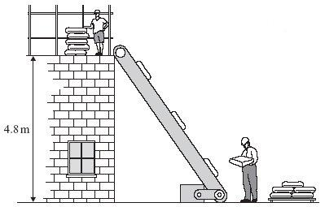
(a) (i) Write down the equation that links change in gravitational potential energy, change in vertical height and weight.
______________________________________________________________(1)

(ii) A 25 kg bag of cement is lifted from the ground to the top of the building. Calculate the gain in the gravitational potential energy of the bag of cement.
(On Earth a 1 kg mass has a weight of 10 N.)
______________________________________________________________
______________________________________________________________
Change in gravitational potential energy = ___________________ joules (2)
(b) The conveyor belt delivers six bags of cement each minute to the top of the building.
(i) Calculate the useful energy transferred by the machine each second.
______________________________________________________________
______________________________________________________________
______________________________________________________________
Useful energy transfer each second = ________________________ J (1)
(ii) The machine is 40% efficient.
Use the following equation to calculate the total energy supplied to the machine each second. Show how you work out your answer.

______________________________________________________________
______________________________________________________________
Total energy supplied each second = ________________________ J (2)
(Total 6 marks)
Q10. A train travels from town A to town B.
Figure 1 shows the route taken by the train.
Figure 1 has been drawn to scale.
Figure 1
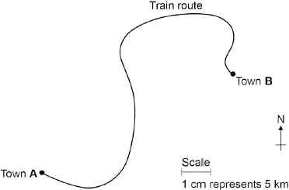
(a) The distance the train travels between A and B is not the same as the displacement of the train.
What is the difference between distance and displacement?
___________________________________________________________________
___________________________________________________________________
___________________________________________________________________(1)
(b) Use Figure 1 to determine the displacement of the train in travelling from A to B.
Show how you obtain your answer.
___________________________________________________________________
___________________________________________________________________
Displacement = ______________ km Direction = ____________________ (2)
(c) There are places on the journey where the train accelerates without changing speed.
Explain how this can happen.
___________________________________________________________________
___________________________________________________________________
___________________________________________________________________(2)
(d) Figure 2 shows how the velocity of the train changes with time as the train travels along a straight section of the journey.
Figure 2
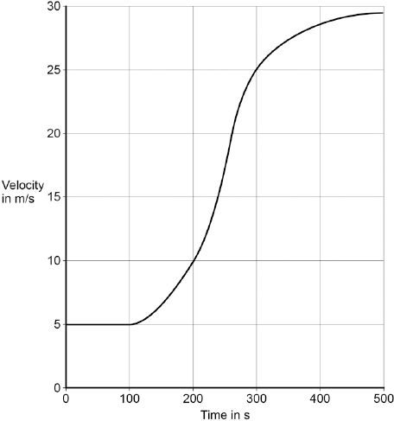
Estimate the distance travelled by the train along the section of the journey shown in Figure 2.
To gain full marks you must show how you worked out your answer.
___________________________________________________________________
___________________________________________________________________
___________________________________________________________________
___________________________________________________________________
Distance = _________________________ m
(3)
(Total 8 marks)
Q11. (a) Some students have designed and built an electric-powered go-kart. After testing, the students decided to make changes to the design of their go-kart.
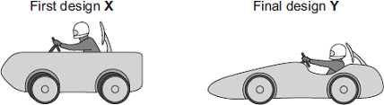
The go-kart always had the same mass and used the same motor.
The change in shape from the first design (X) to the final design (Y) will affect the top speed of the go-kart.
Explain why.
___________________________________________________________________
___________________________________________________________________
___________________________________________________________________
___________________________________________________________________
___________________________________________________________________
___________________________________________________________________(3)

(b) The final design go-kart, Y, is entered into a race.
The graph shows how the velocity of the go-kart changes during the first 40 seconds of the race.
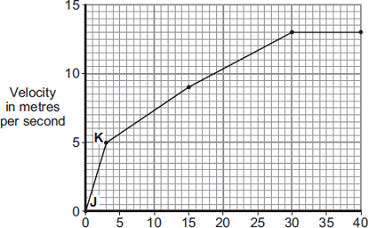
Time in seconds
(i) Use the graph to calculate the acceleration of the go-kart between points J and K.
Give your answer to two significant figures.
______________________________________________________________
______________________________________________________________
______________________________________________________________
Acceleration = ____________________ m/s²
(2)
(ii) Use the graph to calculate the distance the go-kart travels between points J and K.
______________________________________________________________
______________________________________________________________
______________________________________________________________
Distance = ____________________ m
(2)
(iii) What causes most of the resistive forces acting on the go-kart?
______________________________________________________________ (1)
(Total 8 marks)

Q12.(a) Brown dwarf stars are thought to have been formed in the same way as other stars.
They are too small for nuclear fusion reactions to take place in them.
Brown dwarf stars emit infrared radiation but are not hot enough to emit visible light.
(i) Describe how a star is formed.
______________________________________________________________
______________________________________________________________
______________________________________________________________
______________________________________________________________(2)
(ii) Describe the process of nuclear fusion.
______________________________________________________________
______________________________________________________________
______________________________________________________________(1)
(iii) Scientists predicted that brown dwarf stars existed before the first one was discovered in 1995.
Suggest one reason why scientists are now able to observe and identify brown dwarf stars.
______________________________________________________________
______________________________________________________________
______________________________________________________________(1)
(b) In the 18th century some scientists suggested a theory about how the planets formed in the Solar System. The theory was that after the Sun formed, there were cool discs of matter rotating around the Sun. These cool discs of matter formed the planets. The scientists thought this must have happened around other stars too.
(i) Thinking about this theory, what would the scientists have predicted to have been formed in other parts of the Universe?
______________________________________________________________
______________________________________________________________(1)
(ii) Since the 1980s scientists studying young stars have shown the stars to be surrounded by cool discs of rotating matter.
What was the importance of these observations to the theory the scientists suggested in the 18th century?
______________________________________________________________
______________________________________________________________(1)

(c) The Earth contains elements heavier than iron.
Why is the presence of elements heavier than iron in the Earth evidence that the Solar System was formed from material produced after a massive star exploded?
___________________________________________________________________
___________________________________________________________________(1)
(Total 7 marks)
Q13.(a) The ‘Big Bang’ theory uses red-shift as evidence to explain the beginning of the Universe.
How does the red-shift from distant galaxies provide evidence for the beginning of the Universe?
___________________________________________________________________
___________________________________________________________________
___________________________________________________________________
___________________________________________________________________
___________________________________________________________________
___________________________________________________________________(3)
(b) Cosmic microwave background radiation (CMBR) is a type of electromagnetic radiation. CMBR fills the Universe. It was first discovered in 1965 by two astronomers called Penzias and Wilson.
(i) What do scientists believe is the origin of CMBR?
______________________________________________________________
______________________________________________________________(1)
(ii) Why was the discovery of CMBR so important to the scientists believing the ‘Big Bang’ theory to be correct?
______________________________________________________________
______________________________________________________________(1)
(iii) How is the wavelength of CMBR likely to change, if at all, over the next billion years?
______________________________________________________________
Give a reason for your answer.
______________________________________________________________
______________________________________________________________(2)
(Total 7 marks)

Mark schemes
Q1.(a) speed
must be in correct order
1
direction
1
(b)
Quantity | Scalar | Vector
Momentum
Acceleration
Distance
Force
Time
any three correct scores 2 marks
any two correct scores 1 mark
only one correct scores zero
3
(c) (i) 16 and 2
16 or 2 scores 2 marks
allow 1 mark for correct substitution, ie
8 × 2
or
4 × 0.5
3
kg m / s or N s
1
(ii) 1.5 (m / s)
or
their p_{A} + p_{B} = 12 × v correctly calculated
allow 2 marks for correct substitution, ie
18 = 12 × v
or
their p_{A} + p_{B} = 12 × v
18 or their p_{A} + p_{B} scores 1 mark if no other mark awarded
3
(iii) 14 (kg m / s)
or
their p_{A} - p_{B}
1
16.5 (J)
1
[14]
Q2. (a) Each scale optimum
Else both half size
Straight line joining 30,0 to 30,0.67 to 0, 5.67
any 5 for 1 mark each
5
(b) 6
Else a = 30/5
gets 2 marks
Else a = v/t
gets 1 mark
3
(c) 9000
Else F = 6 × 1500
gets 2 marks
Else F = ma
gets 1 mark
3
(d) (i) Driver has forward momentum
Which is conserved
Giving drive relative forward speed to car
for one mark each
3
(ii) Car stops in 75m
gets 1 mark
W = F.d or 9000 × 75
gets 1 mark
W = 675 000 J
OR ke = 1/2 mv²
gets 1 mark
ke = 1/2.1500.302
ke = 675 000 J
3
[17]
Q3.(a) (i) 3
1
(ii) 30 000 or 10 000 × their (a)(i) correctly calculated
1
(iii) any two from:
• frequency is above 20 000 (Hz)
accept the frequency is 30 000
• frequency is above the upper limit of audible range
• upper limit of audible range equals 20 000 (Hz)
ignore reference to lower limit
• it is ultrasound/ultrasonic
2
(b) (i) wave (partially) reflected
1
at crack to produce A and end of bolt to produce B
accept at both ends of the crack
1
(ii) 0.075 (m) allow 2 marks for time = 0.0000125
allow 1 mark for time = 0.000025
answers 0.15 or 0.015 or 0.09 gain 2 marks
answers 0.18 or 0.03 gain 1 mark
the unit is not required but if given must be consistent with numerical answer for the available marks
3
[9]
Q4.(a) (i) frequency
1
wavelength
1
(ii) 10⁻¹⁵ to 10⁴
1
(b) 2.0 × 10⁵
correct substitution of
3.0 × 10⁸ / 1500 gains 1 mark
2
Hz
1
(c) (i) (skin) burns
1
(ii) skin cancer / blindness
1
(d) (i) any one from:
• (detecting) bone fractures
• (detecting) dental problems
• treating cancer
1
(ii) any one from:
• affect photographic film
• absorbed by bone
• transmitted by soft tissue
• kill (cancer) cells
answer must link to answer given in (d)(i)
1
(iii) 9 / 36 = 0.25
0.5 / 2 = 0.25
4 / 16 = 0.25
accept:
36 / 9 = 4
2 / 0.5 = 4
16 / 4 = 4
2
conclusion based on calculation
two calculations correct with a valid conclusion scores 2 marks
one correct calculation of k scores 1 mark
1
[13]
Q5.
(a) light (inside the tin can) is reflected many times before incident on the hole
1
at each reflection energy / light is absorbed so (very) little light / energy leaves the hole
1
(b) the object absorbs all of the radiation incident on it
or
the object does not reflect or transmit any radiation
or
the object is the best possible emitter of radiation
1
(c) the intensity of every wavelength increases
1
the shorter the wavelength the more rapid the increase in intensity
1
the peak intensity occurs at shorter wavelength
1
(d) accept any value between 1600 (°C) and 10 000 (°C)
1
(e) the temperature has increased
1
as 200 years ago the energy / radiation from space = energy / radiation emitted (and reflected) into space
1
but now less radiation is emitted so there is a net absorption
allow energy for radiation
1
[10]
Q6.(a) the image would decrease in size
1
the image would change (from virtual) to real
accept that the image (of bulb M) can be projected on to a screen
1
the image would change (from non-inverted) to inverted
1
(b) a ray through the centre of the lens
rays should be drawn with a ruler
ignore arrows
1
a ray parallel to the principal axis and passing through the principal focus to the right of lens
accept solid or dashed lines
accept a ray drawn as if from the principal focus to the left of the lens, emerging parallel to the principal axis
1
image drawn where rays cross
image should be to left of the lens
1
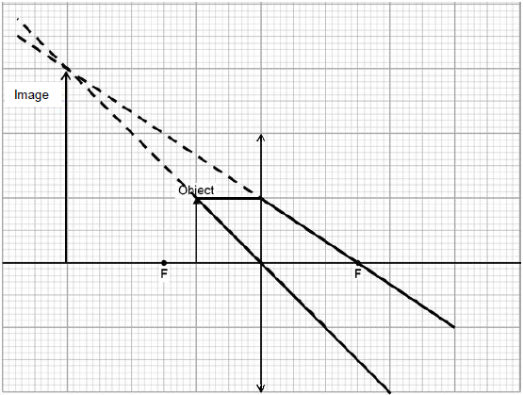
(c) (i) (because the glass in) lens A has a greater refractive index
accept lens A is more powerful
accept lens A has a shorter focal length
1
(ii) when the magnification increases by 1, the image distance increases by 10 cm
accept for 1 mark it is a linear pattern
or
as the image distance increases, the magnification increases
do not accept directly proportional
2
(iii) diagram showing the surfaces of a convex lens C having greater curvature than lens B
the size of the lens drawn is not important
1
[10]
Q7.(a) (i) turning
accept turning ringed in the box
1
(ii) point at which mass (or weight) may be thought to be concentrated
accept the point from which the weight appears to act
allow focused for concentrated
do not accept most / some of the mass
do not accept region / area for point
1
(b) 600 (Nm)
400 × 1.5 gains 1 mark provided no subsequent steps shown
2
(c) (i) plank rotates clockwise
accept girl moves downwards
do not accept rotates to the right
1
(total) CM > (total) ACM
accept moment is larger on the girl’s side
1
weight of see-saw provides CM
answer must be in terms of moment
maximum of 2 marks if there is no reference to the weight of the see-saw
1
(ii) W = 445 (N)
W × 1.5 = (270 × 0.25) + (300 × 2.0) gains 2 marks
allow for 1 mark:
total CM = total ACM either stated or implied
or
(270 × 0.25) + (300 × 2.0)
if no other marks given
3
[10]
Q8.(a) (i) distance vehicle travels during driver’s reaction time
accept distance vehicle travels while driver reacts
1
(ii) any two from:
• tiredness
• (drinking) alcohol
• (taking) drugs
• speed
• age
accept as an alternative factor distractions, eg using a mobile phone
2
(b) (i) 320 000
allow 1 mark for correct substitution, ie × 1600 × 20² provided no subsequent step shown
2
(ii) 320000 or their (b)(i)
1
(iii) 40
or
correctly calculated
allow 1 mark for statement work done = KE lost
or
allow 1 mark for correct substitution, ie
8000 × distance = 320 000 or their (b)(ii)
2
(iv) any one from:
• icy / wet roads
accept weather conditions
• (worn) tyres
• road surface
• mass (of car and passengers)
accept number of passengers
• (efficiency / condition of the) brakes
1
(v) (work done by) friction
(between brakes and wheel)
do not accept friction between road and tyres / wheels
1
(causes) decrease in KE and increase in thermal energy
accept heat for thermal energy accept
KE transferred to thermal energy
1
(c) the battery needs recharging less often
accept car for battery
1
or
increases the range of the car
accept less demand for other fuels or lower emissions or lower fuel costs
environmentally friendly is insufficient
as the efficiency of the car is increased
accept it is energy efficient
1
the decrease in (kinetic) energy / work done charges the battery (up)
accept because not all work done / (kinetic) energy is wasted
1
[14]
Q9.(a) (i) gpe = weight height
accept Ep = mgh
accept pe= mgh
1
(ii) 1200
accept values using 9.8 (1)
allow 1 mark for correct substitution
2
(b) (i) 120
accept 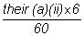
1
(ii) 300
allow b(i) ÷ 0.4 for both marks
allow 1 mark for correct transformation
2
[6]
Q10.(a) distance is a scalar and displacement is a vector
or
distance has magnitude only, displacement has magnitude and direction
1
(b) 37.5 km
accept any value between 37.0 and 38.0 inclusive
1
062° or N62°E
accept 62° to the right of the vertical
1
accept an angle in the range 60° −64°
accept the angle correctly measured and marked on the diagram
(c) train changes direction so velocity changes
1
acceleration is the rate of change of velocity
1
(d) number of squares below line = 17
accept any number between 16 and 18 inclusive
1
each square represents 500 m
1
distance = number of squares × value of each square correctly calculated − 8500 m
1
[8]
Q11.(a) more streamlined
accept decrease surface area
1
air resistance is smaller (for same speed)
accept drag for air resistance
friction is insufficient
1
so reaches a higher speed (before resultant force is 0)
ignore reference to mass
1
(b) (i) 1.7
allow 1 mark for correct method, ie
or allow 1 mark for an answer with more than 2 sig figs that rounds to 1.7
or allow 1 mark for an answer of 17
2
(ii) 7.5
allow 1 mark for correct use of graph, eg × 5 × 3
2
(iii) air (resistance)
accept wind (resistance)
drag is insufficient
friction is insufficient
1
[8]
Q12.(a) (i) (enough) dust and gas (from space) is pulled together
accept nebula for dust and gas
accept hydrogen for gas
accept gas on its own
dust on its own is insufficient
mention of air negates this mark
1
by:
gravitational attraction
or
gravitational forces
or
gravitaty
ignore any (correct) stages beyond this
1
(ii) joining of two (atomic) nuclei (to form a larger one)
do not accept atoms for nuclei
1
(iii) more sensitive astronomical instruments / telescopes
or
infrared telescopes developed
accept better technology
more knowledge is insufficient
1
(b) (i) (other) planets / solar systems
do not accept galaxy
moons is insufficient
1
(ii) provided evidence to support theory
accept proves the theory
1
(c) elements heavier than iron are formed only when a (massive) star explodes
accept materials for elements
accept supernova for star explodes
accept stars can only fuse elements up to (and including) iron
1
[7]
Q13.
(a) any three from:
• red-shift shows galaxies are moving away (from each other / the Earth)
• more distant galaxies show bigger red-shift
or
more distant galaxies show a greater increase in wavelength
accept correct reference to frequency in place of wavelength
• (in all directions) more distant galaxies are moving away faster
accept (suggests) universe is expanding
• suggests single point of origin (of the universe)
3
(b) (i) (radiation produced shortly after) ‘Big Bang’
accept beginning of time / beginning of the universe for ‘Big Bang’
1
(ii) any one from:
• can only be explained by ‘Big Bang’
• existence predicted by ‘Big Bang’
• provides (further) evidence for ‘Big Bang’
ignore proves ‘Big Bang’ (theory)
ignore reference to red-shift
1
(iii) increase
accept becomes radio waves
1
universe continues to accelerate outwards
accept as universe continues to expand
or
greater red-shift
1
[7]

