Q1. Figure 1 shows an electric wheelchair.
Figure 1
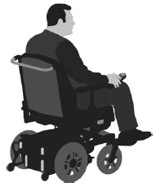
(a) The wheelchair moves at a constant speed of 2.4 m/s for 4.5 seconds.
Calculate the distance moved by the wheelchair.
Use the equation:
distance = speed × time
___________________________________________________________________
___________________________________________________________________
___________________________________________________________________
___________________________________________________________________
Distance = ____________________ m
(2)
(b) What could be a reason for the speed of the wheelchair decreasing?
Tick one box.

It started going downhill. | 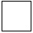
It started going uphill.
Its store of kinetic energy increased.
It used more power from its battery.
(1)

A student measured how the distance travelled by the wheelchair changed over time.
Figure 2 shows a sketch-graph of the results.
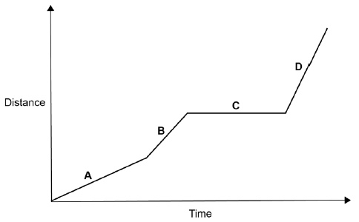
(c) In which section of the graph, A, B, C, or D, did the wheelchair travel fastest?
Give the reason for your answer.
Section ____________________
Reason ____________________________________________________________
___________________________________________________________________(2)
(d) The student used a data logger with a distance sensor to record the data.
Give two advantages of using a data logger rather than using a stopclock and tape measure.
1. _________________________________________________________________
___________________________________________________________________
2. _________________________________________________________________
___________________________________________________________________(2)
The velocity of the wheelchair changes as it accelerates to its top speed.
Figure 3 shows a sketch-graph of the changes.
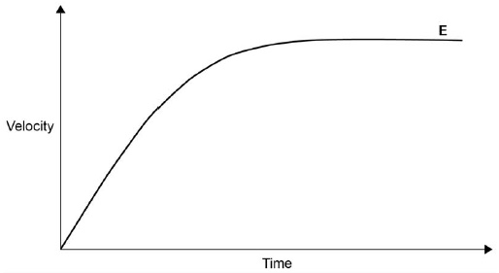
(e) The forward force on the wheelchair is constant as it accelerates on flat ground.
Which force reduces the acceleration?
Tick one box.

Air resistance
Magnetism
Tension
Weight
(1)
(f) Explain the acceleration of the wheelchair at point E on Figure 3.
___________________________________________________________________
___________________________________________________________________
___________________________________________________________________
___________________________________________________________________
(2)
(g) The wheelchair starts from rest.
It accelerates at a constant rate until it has a speed of 1.5 m/s
The wheelchair travels a distance of 2.0 m while it is accelerating.
Calculate the acceleration of the wheelchair.
Using the Physics Equations Sheet.
___________________________________________________________________
___________________________________________________________________
___________________________________________________________________
___________________________________________________________________
___________________________________________________________________
___________________________________________________________________
Acceleration = ____________________ m/s²
(3)
(Total 13 marks)

Q2.
Figure 1 shows a velocity–time graph for a short car journey.
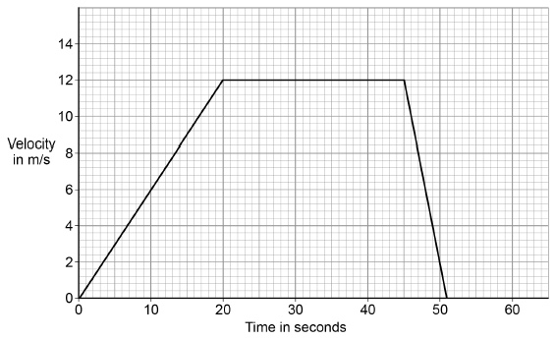
(a) Determine the acceleration of the car in the first 20 seconds of the journey.
Give the unit.
___________________________________________________________________
___________________________________________________________________
___________________________________________________________________
___________________________________________________________________
Acceleration = ____________________ Unit ____________________
(3)
(b) Determine the total distance travelled by the car during the journey shown in Figure 1.
___________________________________________________________________
___________________________________________________________________
___________________________________________________________________
___________________________________________________________________
___________________________________________________________________
___________________________________________________________________
___________________________________________________________________
Total distance travelled = ____________________ m
(4)
(c) The driver had to stop suddenly.
The car’s shock absorbers are springs.
At one point while the car was braking, one shock absorber had an elastic potential energy of 258 J. The spring constant of the shock absorber is 45 300 N/m
Calculate the extension of the shock absorber. Use the Physics Equations Sheet.
___________________________________________________________________
___________________________________________________________________
___________________________________________________________________
___________________________________________________________________
___________________________________________________________________
___________________________________________________________________
Extension = ____________________ m (3)
The stopping distance of a car can be affected by the condition of both the tyres and the road.
• The ‘tread depth’ of a tyre is the depth of the grooves in the tyre.
• Most roads have surfaces made of asphalt.
• Some roads have surfaces made of concrete.
Figure 2 shows how these factors affect the stopping distance for a car travelling at a certain speed.
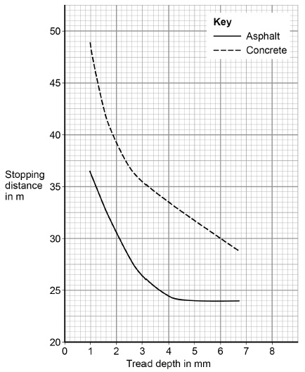
(d) Give three conclusions about the factors affecting stopping distance that can be made from Figure 2.
1. _________________________________________________________________
___________________________________________________________________
2. _________________________________________________________________
___________________________________________________________________
3. _________________________________________________________________
___________________________________________________________________(3)
(e) The lowest stopping distance shown on Figure 2 is 24 m
Explain why the stopping distance does not go below 24 m
___________________________________________________________________
___________________________________________________________________
___________________________________________________________________
___________________________________________________________________(2)
(Total 15 marks)
Q3. Figure 1 shows a cyclist with a trailer attached to his bike.
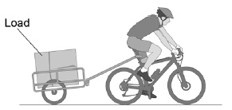
(a) Describe how Newton’s Third Law applies to the forces between the bike and the trailer.
___________________________________________________________________
___________________________________________________________________
___________________________________________________________________
___________________________________________________________________(2)
(b) A student investigated how the stopping distance of the bike was affected by the mass of the load.
The same person rode the same bike throughout the investigation.
Give two other variables which the student should have controlled.
1. _________________________________________________________________
___________________________________________________________________
2. _________________________________________________________________
___________________________________________________________________(2)
(c) Figure 2 shows the results of the investigation.
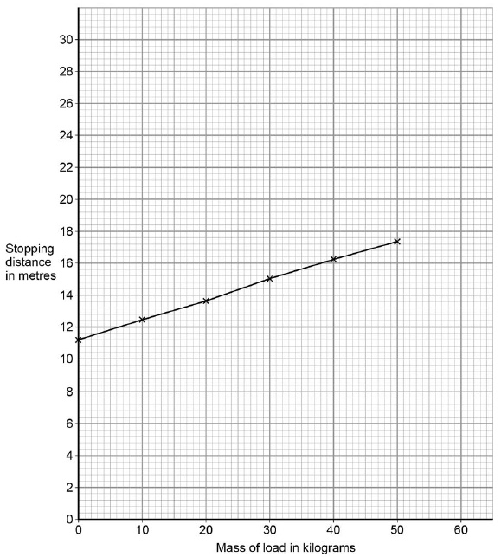
Draw a line on Figure 2 to show how the stopping distance would be different if a heavier cyclist rode the bike. (1)
(d) At one time in the investigation the cyclist was distracted.
The distraction increased the stopping distance of the bike but did not affect the braking distance. Explain why the stopping distance increased.
___________________________________________________________________
___________________________________________________________________
___________________________________________________________________
___________________________________________________________________
___________________________________________________________________
___________________________________________________________________(3)
(Total 8 marks)
Q4. (a) The table gives information about the frequencies in the hearing ranges of six different mammals.

Name of mammal | Frequencies in hearing range
Bat | 20 Hz → 160 kHz
Dog | 20 Hz → 30 kHz
Dolphin | 40 Hz → 110 kHz
Elephant | 5 Hz → 10 kHz
Human | 20 Hz → 20 kHz
Tiger | 30 Hz → 50 kHz
(i) Which mammal in the table can hear the highest frequency?
______________________________________________________________(1)
(ii) Which mammal in the table, apart from humans, cannot hear ultrasound?
______________________________________________________________(1)
(iii) Give one example of a frequency which an elephant can hear but which a tiger cannot hear.
Include the unit in your answer.
Frequency ______________________________(1)
(b) The diagrams show six sound waves, A, B, C, D, E and F, represented on an oscilloscope screen. They are all drawn to the same scale.
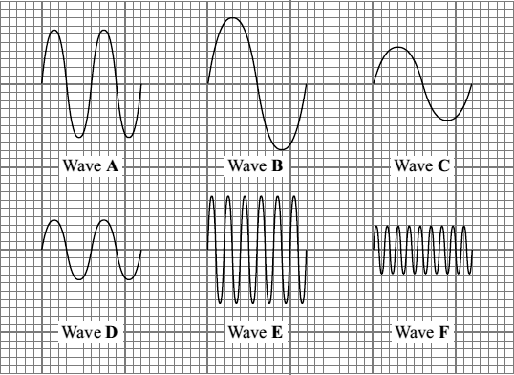
(i) Which one of the waves has the greatest amplitude?
Wave ______________________________(1)
(ii) Which one of the waves has the highest frequency?
Wave ______________________________(1)
(Total 5 marks)
Q5. (a) Complete the sentences.
Choose the answers from the box.

ionising | light | sound | transmitted | waves
X-rays travel at the speed of ____________________ .
X-rays can cause cancer because they are ____________________ . (2)
(b) How do X-rays compare with gamma rays?
Tick one box.

X-rays have a longer wavelength and a higher frequency
X-rays have a longer wavelength and a lower frequency
X-rays have a shorter wavelength and a higher frequency
X-rays have a shorter wavelength and a lower frequency
(1)
A scientist measured the radiation dose that a person received at different distances from an X-ray machine. The table shows the results.

Distance from machine in m | Dose in millisieverts/ |  |  | Mean dose in millisieverts
Distance from machine in m | Test 1 | Test 2 | Test 3 | Mean dose in millisieverts
0.5 | 0.152 | 0.146 | 0.155 | 0.151
1.0 | 0.039 | 0.035 | 0.040 | X
1.5 | 0.017 | 0.018 | 0.017 | 0.017
2.0 | 0.012 | 0.007 | 0.007 | 0.009
2.5 | 0.007 | 0.006 | 0.005 | 0.006
(c) Calculate value X in the table.
___________________________________________________________________
___________________________________________________________________
___________________________________________________________________
Mean dose = ____________________ millisieverts (2)
(d) What conclusion can be made from the results in the table?
Tick one box.

The dose decreases if you stand further from the machine.
The dose is directly proportional to the distance.
The dose is the same at all distances from the machine.
There is a linear relationship between dose and distance.
(1)
(e) An X-ray gives a radiation dose of 0.180 millisieverts.
Natural sources give a dose of 0.012 millisieverts per day.
Calculate the time it would take for natural sources to give a dose of 0.180 millisieverts.
___________________________________________________________________
___________________________________________________________________
___________________________________________________________________
Time = ____________________ days
(2)
(f) Suggest why doctors use X-rays even though this increases the risk of cancer to the patient.
___________________________________________________________________
___________________________________________________________________
(1)
(g) X-rays can also be used to treat cancer.
A patient receives a dose of 20 millisieverts from an X-ray.
Proton beam therapy delivers 40% of this dose.
Calculate the dose delivered by proton beam therapy.
___________________________________________________________________
___________________________________________________________________
___________________________________________________________________
Dose = ____________________ millisieverts
(2)
(Total 11 marks)
Q6. A group of students investigate the features of waves.
Figure 1 shows some of the equipment they use.
Figure 1
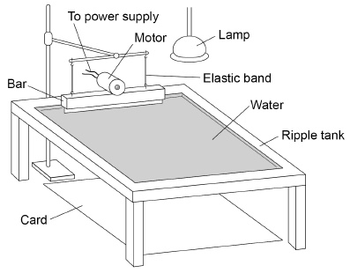
(a) Write the equation which links frequency, wavelength and wave speed.
___________________________________________________________________
(1)
(b) The students want to determine the wave speed of water waves in the ripple tank.
Describe a method the students could use.
___________________________________________________________________
___________________________________________________________________
___________________________________________________________________
___________________________________________________________________
___________________________________________________________________
___________________________________________________________________
___________________________________________________________________
___________________________________________________________________
___________________________________________________________________
___________________________________________________________________
(4)

Figure 2 and Figure 3 show the ‘magic coin’ trick.
A coin is glued to the bottom of a bowl and an observer stands where they cannot see the coin (Figure 2).
Figure 2
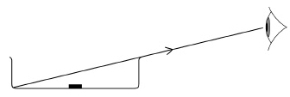
Another person fills the bowl with water.
The observer and the coin do not move.
After the water is added the observer can see the coin (Figure 3).
Figure 3
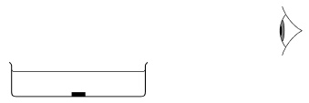
(c) Explain why the observer can now see the coin in Figure 3.
___________________________________________________________________
___________________________________________________________________
___________________________________________________________________
___________________________________________________________________
___________________________________________________________________
___________________________________________________________________(3)
(d) Some types of wave are longitudinal and some types of wave are transverse.
Describe the difference between longitudinal waves and transverse waves.
___________________________________________________________________
___________________________________________________________________
___________________________________________________________________
___________________________________________________________________
___________________________________________________________________
_________________________________________________________(2)(Total 10 marks)
Q7. Figure 1 is a wave front diagram showing light travelling through the air and into a glass block.
Figure 1
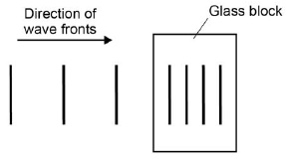
(a) Complete Figure 1 by drawing wave fronts after they have left the glass block.
(1)
(b) Figure 2 shows a ray of light incident on a semi-circular glass block.
Figure 2
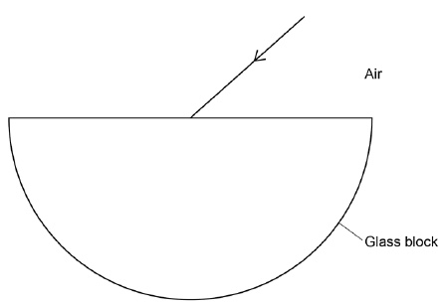
Complete the ray diagram in Figure 2.
• Draw the ray of light passing through and leaving the glass block.
• Label the angle of refraction.
(4)
(c) Explain why the light is refracted.
___________________________________________________________________
___________________________________________________________________
___________________________________________________________________
___________________________________________________________________
(2)
(d) A student investigated how different coloured light was refracted by glass.
The student aimed rays of different coloured light at a glass block.
She measured the angle of refraction for each colour.
Give two variables that the student should control.
1. _________________________________________________________________
2. _________________________________________________________________(2)
The table shows the student's results.

Colour of light | Angle of refraction in degrees
Red | 27.94
Orange | 27.90
Yellow | 27.82
Green | 27.78
Blue | 27.70
(e) Explain why these results could not have been obtained with a normal protractor.
___________________________________________________________________
___________________________________________________________________
___________________________________________________________________
___________________________________________________________________(2)
(f) What conclusion can be made about the relationship between the wavelength of light and the angle of refraction?
___________________________________________________________________
___________________________________________________________________(1)
(g) Glass does not transmit ultraviolet radiation.
Suggest what happens to ultraviolet radiation when it is incident on glass.
___________________________________________________________________
___________________________________________________________________(1)
(Total 13 marks)
Q8. A note was played on an electric keyboard.
The frequency of the note was 440 Hz.
(a) (i) What does a frequency of 440 Hz mean?
______________________________________________________________
______________________________________________________________(1)

(ii) The sound waves produced by the keyboard travel at a speed of 340 m / s.
Calculate the wavelength of the note.
Give your answer to three significant figures.
______________________________________________________________
______________________________________________________________
______________________________________________________________
Wavelength = ____________________ metres (3)
(b) Figure 1 shows a microphone connected to a cathode ray oscilloscope (CRO) being used to detect the note produced by the keyboard.
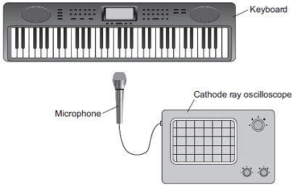
Figure 2 shows the trace produced by the sound wave on the CRO.
Figure 2
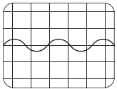
A second note, of different wavelength, was played on the keyboard.
Figure 3 shows the trace produced by the sound wave of the second note on the CRO.
Figure 3
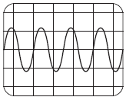
The settings on the CRO were unchanged.
What two conclusions should be made about the second sound wave produced by the keyboard compared with the first sound wave?
Give a reason for each conclusion.
Conclusion 1 ________________________________________________________
___________________________________________________________________
Reason ____________________________________________________________
___________________________________________________________________
Conclusion 2 ________________________________________________________
___________________________________________________________________
Reason ____________________________________________________________
___________________________________________________________________(4)
(Total 8 marks)
Q9.
A teacher used the equipment shown in the figure below to demonstrate the motor effect.
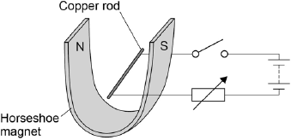
(a) Describe how Fleming’s left-hand rule can be used to determine the direction in which the rod will move when the switch is closed, and state the direction.
___________________________________________________________________
___________________________________________________________________
___________________________________________________________________
___________________________________________________________________
___________________________________________________________________
___________________________________________________________________
___________________________________________________________________
___________________________________________________________________
___________________________________________________________________
(4)
(b) Increasing the current can increase the force acting on the copper rod.
Give one other way in which the size of the force acting on the copper rod could be increased.
___________________________________________________________________
___________________________________________________________________
(1)
(c) The copper rod in the figure above has a length of 7 cm and a mass of 4 ×10^{–4} kg.
When there is a current of 1.12 A the resultant force on the copper rod is 0 N.
Calculate the magnetic flux density.
Gravitational field strength = 9.8 N / kg
___________________________________________________________________
___________________________________________________________________
___________________________________________________________________
___________________________________________________________________
___________________________________________________________________
___________________________________________________________________
Magnetic flux density = __________________ T
(5)
(Total 10 marks)

Mark schemes
Q1.(a) distance = 2.4 m/s × 4.5 s
1
distance = 10.8 (m)
an answer of 10.8 m scores 2 marks
1
(b) It started going uphill.
1
(c) D
1
the line has the largest gradient
allow it is steepest
allow it travels the furthest distance in the shortest amount of time
1
(d) any two from:
• the data logger records time more accurately
• the data logger can take readings more frequently
• there is less chance for human error when using a data logger
• the data logger automatically records data
allow the converse of each argument, eg there is a human reaction time error when using a stopclock
2
(e) air resistance
1
(f) acceleration is zero
1
because the resultant force is zero
allow because the forward force equals the air resistance
there is too much air resistance is insufficient
1
(g) v² – u² = 2as
1.5² (– 0²) = 2 × a × 2
1
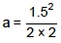
1
a = 0.56(25) m/s²
an answer of 0.56(25) (m/s²) scores 3 marks
1
[13]
Q2.(a) a = 12/20
1
= 0.6
1
m/s2
an answer of 0.6 scores 2 marks
if first 2 marks not awarded, allow 1 mark for an attempt to determine a = ∆ v/t with incorrect values from graph
allow ms⁻²
1
(b) (first calculate area under graph) 20s: 0.5 × 20 × 12 = 120 (m)
1
next 25s: 25 × 12 = 300 (m)
1
final 6s: 0.5 × 6 × 12 = 36 (m)
1
total: 120 + 300 + 36 = 456 (m)
an answer of 456 (m) scores 4 marks
1
(c) 258 = 45 300 × e²
1
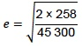
1
= 0.107 (m)
an answer of 0.107 (m) scores 3 marks
allow 0.11, 0.106727...
1
(d) stopping distances lower on asphalt than concrete (for all tread depths)
1
as tread depth increases, stopping distance decreases
1
below a certain tread depth, stopping distance increases much faster
if values quoted, expect to see
4 mm for asphalt and 2.5 mm for concrete
1
(e) stopping distance also includes thinking distance
allow stopping distance = thinking distance + braking distance
1
braking distance can never be zero
1
[15]
Q3.(a) the forces of the bike on the trailer and the trailer on the bike are equal in size
allow the force of tension acts on the bike and the trailer
1
and opposite in direction
1
(b) any two from:
• the same trailer should be used
• the weather conditions should be the same
allow a description of this, eg the wind should be the same
• the same road (surface) should be used
• the same gradient road should be used
• the same speed should be used
• the cyclist should be at the same level of alertness throughout the experiment
allow a description of a cause of this eg the cyclist should not drink coffee between experiments
2
(c) straight line drawn above the original line, sloping upwards
1
(d) the cyclist’s reaction time increased
1
so the thinking distance increased
1
stopping distance is thinking distance plus braking distance
1
[8]
Q4.(a) (i) bat(s)
1
(ii) elephant(s)
1
(iii) any example in the inclusive range 5 ↔ 29 Hz / hertz
appropriate number and unit both required
1
(b) (i) B
1
(ii) F
1
[5]
Q5.(a) light
1
ionising
1
(b) x-rays have a longer wavelength and a lower frequency
1
(c) 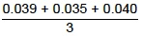
1
= 0.038 (milllisieverts)
an answer of 0.038 scores 2 marks
1
(d) the dose decreases if you stand further from the machine
1
(e) 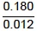
1
= 15 days
an answer of 15 days scores 2 marks
1
(f) the benefit (of a correct diagnosis) outweighs the risk
allow the (increased) risk of cancer is very small for an x-ray
allow for medical imaging, eg to see broken bones
1
(g) 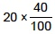
allow 20 × 40%
1
= 8 (millisieverts)
an answer of 8 (millisieverts) scores 2 marks
1
[11]
Q6.(a) wave speed = frequency × wavelength
allow v = f λ
1
(b)
Level 2: The design/plan would lead to the production of a valid outcome. All key steps are identified and logically sequenced. | 3-4
Level 1: The design/plan would not necessarily lead to a valid outcome. Most steps are identified, but the plan is not fully logically sequenced. | 1-2
No relevant content | 0
Indicative content
• adjust the bar so that it just touches the surface of the water
• adjust motor to produce low frequency wave
• adjust the lamp until the pattern is seen clearly on the card underneath
• place a metre rule at right angles to the waves
• measure the length of a number of waves (minimum 3 waves)
• divide the length by the number of waves to give wavelength
• count the number of waves passing a point in a given time
• divide the number of waves counted by the time to give the frequency
4
(c) light is reflected off the coin (and travels through the water)
allow correct ray on diagram
1
as the light leaves the water its speed increases
allow correct ray on diagram
1
(this causes) the light to refract in the direction of the eye
1
(d) in longitudinal waves oscillations are parallel to the direction of energy transfer
1
in transverse waves the oscillations are perpendicular to the direction of energy transfer
1
[10]
Q7.(a) at least two wave fronts drawn to the right of the glass block, parallel to the other wave fronts and with equal spacing compared with the wave fronts to the left of the glass block
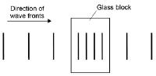
1
(b) ray of light refracts towards the normal where it is incident on the glass block
1
ray of light does not refract when it exits the glass block
1
a normal is drawn on where the ray is incident on the glass block
1
the angle of refraction is labelled
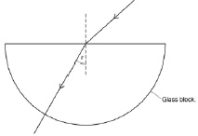
lines should be drawn with a ruler
1
(c) light travels more slowly (in the glass block than in the air)
1
so it changes direction
allow so it bends towards the normal
1
(d) the angle of incidence
1
the type of glass used
allow the glass block
1
(e) the resolution of a normal protractor is too big
1
so it could not measure the difference between results
allow so it could not read angles to 2 decimal places
1
(f) a longer wavelength gives a greater angle of refraction
1
(g) absorbed / reflected
1
[13]
Q8.(a) (i) 440 (sound) waves produced in one second
accept vibrations / oscillations for waves
1
(ii) 0.773 (metres)
allow 2 marks for an answer that rounds to 0.773
allow 2 marks for an answer of
allow 2 marks for an answer of 0.772
allow 1 mark for correct substitution ie 340 = 440 × λ
3
(b) (sound is) louder
do not accept the converse
1
as amplitude is larger
waves are taller is insufficient
1
higher pitch / frequency
1
as more waves are seen
reference to wavelengths alone is insufficient
waves are closer together is insufficient
1
[8]
Q9.(a) thumb, index finger and third finger are held mutually at right angles
1
index finger shows the direction of the magnetic field from North to South, third finger
shows the direction of the current from positive to negative terminal
1
the thumb then shows the direction of the force acting on the copper rod
1
so the copper rod will move upwards
1
(b) any one from:
use a stronger magnet
increase the magnetic flux density
increase the length of the copper rod in the magnetic field
coil the copper rod
1
(c) W = 9.8 × 4×10^{–4} = 3.92 × 10^{–3}
1
conversion of the length 7cm to 0.07m
1
3.92 × 10^{–3} = B × 1.12 × 0.07
1
B = 3.92 × 10^{–3} / 0.0784
1
B = 0.05 (T)
1
allow 0.05 (T) without working shown for the 5 calculation marks [10]

