Q1.On 7th June 2017 more than 50% of the electricity generated in the UK was from renewable sources.
(a) Suggest two environmental conditions in the UK on 7th June 2017.
1. _________________________________________________________________
___________________________________________________________________
2. _________________________________________________________________
___________________________________________________________________(2)
(b) At midday 35.4 GW of electricity was generated.
20.8% of this was provided by gas-fired power plants.
Calculate the energy per second that was provided by gas-fired power stations.
___________________________________________________________________
___________________________________________________________________
___________________________________________________________________
Energy per second = ____________________ J (3)
(c) Some of the electricity generated was from low-carbon sources.
Low-carbon sources emit very little carbon dioxide.
Name one non-renewable resource that is a low-carbon source.
___________________________________________________________________(1)
(d) In the UK, electricity is delivered to consumers by the National Grid.
Explain the main features of the National Grid.
___________________________________________________________________
___________________________________________________________________
___________________________________________________________________
___________________________________________________________________
___________________________________________________________________
___________________________________________________________________
___________________________________________________________________
___________________________________________________________________
___________________________________________________________________
___________________________________________________________________
___________________________________________________________________
___________________________________________________________________
___________________________________________________________________(6)
(e) The National Grid supplied a house with 18 000 000 J of energy in 1 hour.
What was the average current supplied to the house during that hour?
Write any equations that you use.
___________________________________________________________________
___________________________________________________________________
___________________________________________________________________
___________________________________________________________________
___________________________________________________________________
___________________________________________________________________
___________________________________________________________________
___________________________________________________________________
Current = ____________________ A (5) (Total 17 marks)
Q2.
Figure 1 shows a battery operated remote control car.
Figure 1
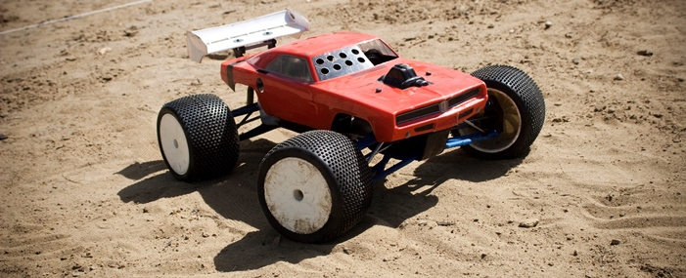
© Brandon Bolin/iStock/Thinkstock
(a) The car’s battery contains a store of energy.
As the car moves, energy from one store is transferred to another store.
Describe how different stores of energy change as the car moves.
___________________________________________________________________
___________________________________________________________________
___________________________________________________________________
___________________________________________________________________
(2)
(b) The car has a top speed of 12 m / s and a mass of 800 g.
Write down the equation that links kinetic energy, mass and speed.
Equation ___________________________________________________________(1)
(c) Calculate the maximum kinetic energy of the car.
___________________________________________________________________
___________________________________________________________________
___________________________________________________________________
Maximum kinetic energy = __________________ J (2)
(d) Explain why having a more efficient motor increases the top speed of the car.
___________________________________________________________________
___________________________________________________________________
___________________________________________________________________
___________________________________________________________________(2)
(e) Figure 2 shows an electric car being charged.
Figure 2
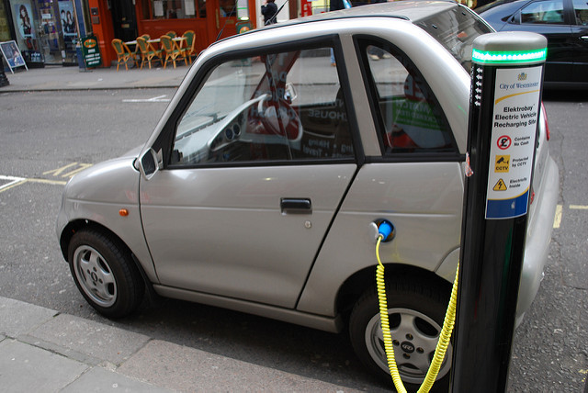
By Alan Trotter Electric Car Charging [CC-BY-2.0]via Flickr
A driver wishes to buy a new car.
The table below gives some data about an electric car and one with a petrol engine.

 | Electric car | Petrol engine car
Cost (£) | 27 000 | 15 000
Running cost per year (£) | 250 | 2 000
Average lifetime (years) | 12 | 12
Which car would be the most economic over its 12 year lifetime?
Use data from the table above to support your answer.
You should include the difference in cost in your answer.
___________________________________________________________________
___________________________________________________________________
___________________________________________________________________
___________________________________________________________________
___________________________________________________________________
___________________________________________________________________
___________________________________________________________________
___________________________________________________________________
___________________________________________________________________(4)
(Total 11 marks)
Q3. Figure 1 shows a student making potato soup.
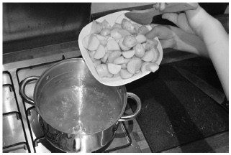
(a) The student places 0.5 kg of potato into a pan of water.
During cooking, the temperature of the potato increases from 20 °C to 100 °C
The specific heat capacity of the potato is 3400 J/kg °C
Calculate the change in thermal energy of the potato.
Use the equation:
change in thermal energy = mass × specific heat capacity × temperature change
___________________________________________________________________
___________________________________________________________________
___________________________________________________________________
___________________________________________________________________
___________________________________________________________________
___________________________________________________________________
Change in thermal energy = ____________________ J (3)
(b) Why is the energy supplied by the cooker greater than that calculated in part (a)?
___________________________________________________________________(1)
(c) Suggest one way that the student could reduce the time to heat the potato to 100 °C
___________________________________________________________________(1)
Figure 2 shows a food processor.
Figure 2
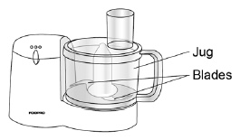
(d) The student places the cooked potato into the jug of the food processor.
The food processor contains a motor that spins blades to chop the potato.
The total power input to the motor is 500 W
The useful power output from the motor is 300 W
Calculate the efficiency of the motor in the food processor.
Use the equation:
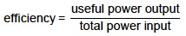
___________________________________________________________________
___________________________________________________________________
___________________________________________________________________
Efficiency = ____________________
(2)
(e) The jug is made of plastic with a low thermal conductivity.
Explain why this is an advantage.
___________________________________________________________________
___________________________________________________________________
___________________________________________________________________
___________________________________________________________________(2)
(Total 9 marks)
Q4. The figure below shows a rollercoaster.
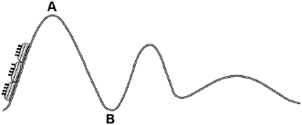
The rollercoaster car is raised a vertical distance of 35 m to point A by a motor in 45 seconds.
The mass of the rollercoaster is 600 kg.
The motor has a power rating of 8 000 W.
(a) Calculate the percentage efficiency of the motor.
Gravitational field strength = 9.8 N / kg.
___________________________________________________________________
___________________________________________________________________
___________________________________________________________________
___________________________________________________________________
___________________________________________________________________
___________________________________________________________________
___________________________________________________________________
Efficiency = __________________ % (5)
(b) The rollercoaster rolls from point A to point B, a drop of 35 m.
Calculate the speed of the roller coaster at point B.
Assume that the decrease in potential energy store is equal to the increase in kinetic energy store.
___________________________________________________________________
___________________________________________________________________
___________________________________________________________________
___________________________________________________________________
___________________________________________________________________
___________________________________________________________________
___________________________________________________________________
Speed at point B = __________________ m / s (6)
(Total 11 marks)
Q5. Figure 1 shows the circuit symbol for three different components.
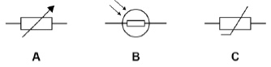
(a) Which component is a variable resistor?
Tick one box.

A |  | B |  | C
(1)
(b) Which component is a thermistor?
Tick one box.

A |  | B |  | C
(1)
(c) In which component will the resistance decrease when the temperature increases?
Tick one box.

A |  | B |  | C
(1)
(d) In which component will the resistance decrease when the light intensity increases?
Tick one box.

A |  | B |  | C
(1)
Figure 2 shows four different arrangements of resistors.
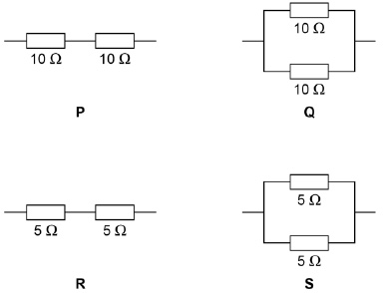
(e) Two of the arrangements are in series and two are in parallel.
Describe the difference between a series and a parallel arrangement.
___________________________________________________________________
___________________________________________________________________
___________________________________________________________________
(2)
(f) Which arrangement has a resistance of 10 Ω?
Tick one box.

P |  | Q |  | R |  | S
(1)
(g) Which arrangement has the highest resistance?
Tick one box.

P |  | Q |  | R |  | S
(1)
(h) A student connects a resistor to a cell for 60 seconds.
The current through the resistor is 0.97 A
Calculate the charge flow.
Use the equation:
charge flow = current × time
Give your answer to 2 significant figures.
___________________________________________________________________
___________________________________________________________________
___________________________________________________________________
___________________________________________________________________
___________________________________________________________________
___________________________________________________________________
Charge flow = ____________________ C
(3)
(Total 11 marks)
Q6. Figure 1 shows a three pin plug connected to the cable of a metal toaster.
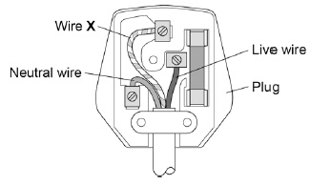
(a) Name wire X.
___________________________________________________________________
(1)
(b) What does wire X do?
Tick one box.

It provides extra energy to the toaster when needed.
It completes the circuit in the toaster.
It can prevent an electric shock from the toaster.
It supplies the current to the toaster.
(1)
(c) The toaster is plugged in to the mains electricity supply.
What is the potential difference between the live and neutral wires?
Tick one box.

0 V |  | 120 V |  | 230 V |  | 460 V
(1)
(d) Mains electricity is an alternating supply.
A battery is a direct supply.
Figure 2 shows an alternating supply and a direct supply.
Figure 2
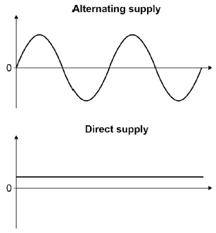
Give two differences between the alternating supply and the direct supply.
1. _________________________________________________________________
2. _________________________________________________________________
(2)
Energy is transferred to homes by the National Grid.
Figure 3 shows the percentage energy losses over the National Grid for different years.
Figure 3
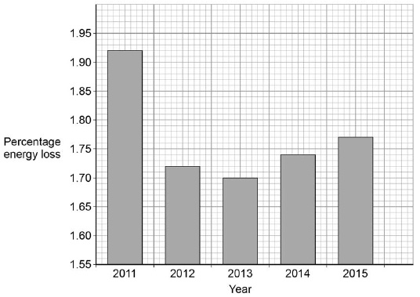
(e) Describe the changes in percentage energy loss.
___________________________________________________________________
___________________________________________________________________
___________________________________________________________________
___________________________________________________________________
(2)
(f) Calculate the mean percentage energy loss per year in Figure 3.
___________________________________________________________________
___________________________________________________________________
___________________________________________________________________
___________________________________________________________________
___________________________________________________________________
___________________________________________________________________
Mean energy loss per year = ____________________ %
(3)
(Total 10 marks)
Q7. (a) Atoms of the isotope bismuth-212 decay by emitting either an alpha particle or a beta particle.The equation represents what happens when an atom of bismuth-212 decays by beta emission into an atom of polonium-212.
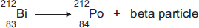
(i) The bismuth atom and the polonium atom have the same mass number (212).
What is the mass number of an atom?
______________________________________________________________
(1)
(ii) Beta decay does not cause the mass number of an atom to change.
Explain why not.
______________________________________________________________
______________________________________________________________
______________________________________________________________
______________________________________________________________
(2)
(b) When an atom of bismuth-212 emits an alpha particle, the atom decays into an atom of thallium.
An alpha particle is the same as a helium nucleus.
The symbol below represents an alpha particle.
(i) The equation below represents the alpha decay of bismuth-212.
Complete the equation by writing the correct number in each of the two boxes.
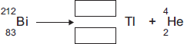
(2)
(ii) It is impossible for the alpha decay of bismuth-212 to produce the same element as the beta decay of bismuth-212.
Explain why.
______________________________________________________________
______________________________________________________________
______________________________________________________________
_____________________________________________________(2)(Total 7 marks)
Q8.Figure 1 shows the label from a box containing radium-226
Radium-226 emits α, β and γ radiation.
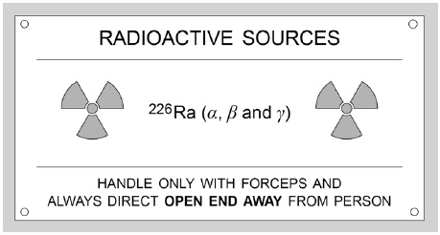
(a) Figure 2 shows how the activity of the radium-226 will change.
Figure 2
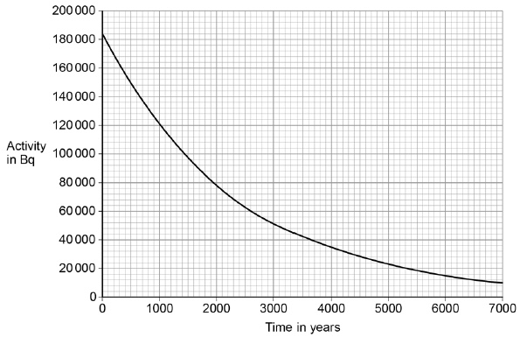
Determine the half-life of radium-226.
Show your working on Figure 2.
___________________________________________________________________
___________________________________________________________________
Half-life = ____________________ years
(2)
(b) Radium-226 was discovered by Marie Curie in 1898. The notebooks she used were contaminated with radium-226 and are still hazardous. Explain why the notebooks are still hazardous.
___________________________________________________________________
___________________________________________________________________
___________________________________________________________________
___________________________________________________________________(2)
(c) Explain how the properties of α, β and γ radiation affect the level of the hazard at different distances.
___________________________________________________________________
___________________________________________________________________
___________________________________________________________________
___________________________________________________________________
___________________________________________________________________
___________________________________________________________________
___________________________________________________________________
___________________________________________________________________
___________________________________________________________________
___________________________________________________________________
___________________________________________________________________
______________________________________________________(6) (Total 10 marks)
Q9. The particle model can be used to explain the properties of gases.
(a) Describe the direction of motion of the particles in a gas.
___________________________________________________________________
___________________________________________________________________(1)
(b) Explain why heating a gas increases the average speed of the gas particles.
___________________________________________________________________
___________________________________________________________________
___________________________________________________________________
___________________________________________________________________
___________________________________________________________________
___________________________________________________________________(3)
(c) Water can exist as either a liquid or a gas at 100 °C.
Explain why a mass of gaseous water at 100 °C contains more energy than an equal mass of liquid water at 100 °C.
___________________________________________________________________
___________________________________________________________________
___________________________________________________________________
___________________________________________________________________
___________________________________________________________________
___________________________________________________________________(2)
(d) Water vapour is a gas. Gases change state when they cool.
The figure below shows condensation on a cold bathroom mirror.
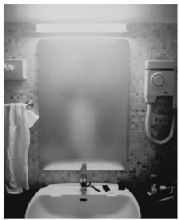
© Dwight Eschliman/Getty Images
A volume of 2.5 × 10^{–5} m³ of condensation forms on the mirror.
Density of water = 1000 kg / m³
Specific latent heat of vaporisation of water = 2.26 × 10⁶ J / kg.
Calculate the energy released when the condensation forms.
___________________________________________________________________
___________________________________________________________________
___________________________________________________________________
___________________________________________________________________
___________________________________________________________________
___________________________________________________________________
___________________________________________________________________
Energy released = _______________________ J
(5)
(e) Central heating boilers burn gas and use the energy released to heat water.
Modern condensing central heating boilers take advantage of the energy that is released when water condenses. Waste water vapour produced when the water is heated in the boiler is used to preheat the cold water entering the boiler. Give some of the arguments in favour of condensing boilers compared to older non-condensing boilers.
___________________________________________________________________
___________________________________________________________________
___________________________________________________________________
___________________________________________________________________
___________________________________________________________________
___________________________________________________________________
___________________________________________________________________
___________________________________________________________________
________________________________________________________(4) (Total 15 marks)
Q10. The diagram shows a model of the particles in a gas and in a liquid.
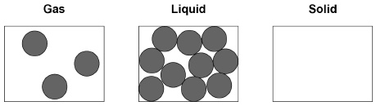
(a) Complete the diagram to show the arrangement of particles of the same substance as a solid.
(2)
(b) What is the name of the process when a substance changes from a gas to a liquid?
Tick one box.

Condensing
Evaporating
Freezing
Melting
(1)
(c) The substance in the diagram has a:
• melting point of 98 °C • boiling point of 883 °C
What is the state of the substance at 20 °C?
Tick one box.

Gas |  | Liquid |  | Solid
(1)

(d) What type of change is a change of state?
Tick one box.

Chemical
Kinetic
Permanent
Physical
(1)
(e) Which two statements are correct about the particles when a liquid turns into a gas?
Tick two boxes.

Particles are bigger
Particles are lighter
Particles have more chemical energy
Particles have more kinetic energy
Particles move faster
(2)
(f) Which two quantities are needed to calculate the energy required to turn a liquid into a gas with no change in temperature?
Tick two boxes.

Mass of the liquid
Specific heat capacity of the gas
Specific latent heat of vaporisation
Time the liquid is heated
(2)
(g) A mass of 2.0 kg of water is heated.
The temperature increase of the water is 80 °C
The specific heat capacity of water is 4200 J / kg °C
Calculate the change in thermal energy when the water is heated.
Use the equation:
change in thermal energy = mass × specific heat capacity × temperature change
___________________________________________________________________
___________________________________________________________________
___________________________________________________________________
Change in thermal energy = ____________________ J (2) (Total 11 marks)
Q11. A student investigates how the length of a piece of wire affects its resistance.
The diagram shows the apparatus used.
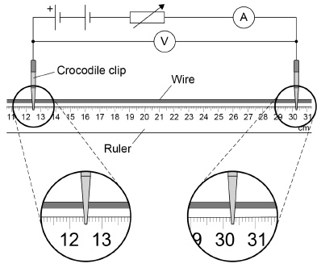
(a) What is the length of wire between the two crocodile clips shown in the diagram?
Length = ____________________ cm (1)
(b) Write the equation which links current, potential difference and resistance.
___________________________________________________________________(1)
(c) For the experiment shown in the diagram, the student recorded:
• a potential difference of 3.22 V
• a current of 2.18 A
Calculate the resistance of the length of wire between the crocodile clips.
Give your answer to 3 significant figures.
___________________________________________________________________
___________________________________________________________________
___________________________________________________________________
___________________________________________________________________
___________________________________________________________________
___________________________________________________________________
___________________________________________________________________
___________________________________________________________________
Resistance = ____________________ Ω (4)
(d) The student used constantan wire.
The resistance of constantan only changes a small amount when its temperature changes.
Suggest why using constantan is an advantage in this experiment.
___________________________________________________________________
___________________________________________________________________
___________________________________________________________________
___________________________________________________________________(2)
The table shows the student's results.

Length in cm | Resistance in Ω
20.0 | 1.67
30.0 | 2.49
40.0 | 3.31
50.0 | 5.26
60.0 | 4.98
70.0 | 5.78
80.0 | 6.65
(e) One of the results in the table is anomalous.
For what length of wire is the resistance anomalous?
Length = ____________________ cm (1)
(f) What could have caused the anomalous result?
Tick one box.

The ammeter gave a reading that was too low.
The wire was shorter than the measured value.
The temperature of the wire decreased.
The voltmeter gave a reading that was too low.
(1)
(Total 10 marks)
Q12. Alpha, beta and gamma are types of nuclear radiation.
A teacher sets up a demonstration of the penetration properties of alpha, beta and gamma radiation.
The figure below shows the demonstration.
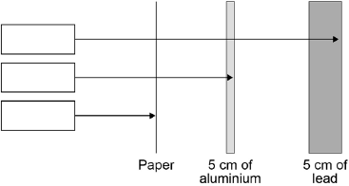
(a) Complete the figure above by writing the name of the radiation in each box.
(2)
(b) Give two safety precautions the teacher should take in the demonstration.
1. _________________________________________________________________
___________________________________________________________________
2. _________________________________________________________________
___________________________________________________________________
(2)
(c) The table below shows how the count rate of a radioactive source changes with time.

Time in seconds | 0 | 40 | 80 | 120 | 160
Count rate in counts / second | 600 | 463 | 300 | 221 | 150
Describe the relationship shown in the table above.
___________________________________________________________________
___________________________________________________________________
___________________________________________________________________
___________________________________________________________________
(2)
(d) Use the table above to predict the count rate after 200 seconds.
___________________________________________________________________
___________________________________________________________________
___________________________________________________________________
Count rate = ____________ counts / second
(2)
(e) The half-life of the radioactive source is very short.
Give one reason why the source would be much less hazardous after 800 seconds.
___________________________________________________________________
_________________________________________________________(1)(Total 9 marks)

Mark schemes
Q1.
(a) very little cloud cover
allow high intensity sunlight
1
favourable wind speed
allow high wind speed
1
(b) 35.4 × 10⁹
allow 35 400 000 000
1
E = 35.4 × 10⁹ × (20.8 / 100)
1
E = 7.4 × 10⁹(J)
an answer of 7.4 × 10⁹(J) or 7 400 000 000 scores 3 marks
allow 7 400 000 000
1
(c) nuclear
1
(d)
Level 3: Relevant points (reasons/causes) are identified, given in detail and logically linked to form a clear account. | 4-6
Level 2: Relevant points (reasons/causes) are identified, and there are attempts at logically linking. The resulting account is not fully clear | 3-4
Level 1: Points are identified and stated simply, but their relevance is not clear and there is no attempt at logical linking. | 1-2
No relevant content | 0
Indicative content
step up transformer
• increases the potential difference
• decreases the current
• reduces heating of transmission cables
• less wasted energy
• more efficient energy transfer
transmission cables
• low resistance
• reduces heating
• reduces wasted energy
step down transformer
• increases the current
• decreases the potential difference
• to a safe level
• the level is suitable for domestic appliances
6
(e) P = E / t

P = 18 000 000 / 3 600
1
P = 5 000
1
P =I V

I = P / V
1
I = 5 000 / 230
1
I = 22 (A)
allow an answer that rounds to 22 (A)
an answer of 22 (A) scores 5 marks
1
[17]
Q2.(a) the store of chemical energy (in the battery) decreases
1
the internal energy of the surrounding air increases.
1
accept description of energy becoming less usefully stored for 2 marks
(b) kinetic energy = ½ mass × velocity²
1
(c) E_{K} = ½ × 0.8 × 12²
1
E_{K} = 57.6 (J)
1
allow 57.6 (J) without working shown for 2 marks
(d) lower proportion of wasted energy
accept less energy is wasted
1
higher proportion of energy is converted into kinetic energy
accept more kinetic energy
1
(e) Level 2 (3–4 marks):
A relevant and coherent argument which demonstrates processing and numerical
analysis of the information presented and draw a conclusion which is logically consistent with the reasoning and refers to payback time for the vehicles.
Level 1 (1–2 marks):
Simple comparisons are made which demonstrate a basic ability to numerically analyse
the information presented. The conclusion, if present, may not be consistent with the calculations.
0 marks:
No relevant content
Indicative content
• The electric car costs £12 000 more to buy
• Running cost of electric car = £3 000
• Running cost of petrol engine car = £24 000
• Total cost of electric car = £30 000
• Total cost of petrol engine car = £39 000
• The electric car cost £1 750 less to run each year
• The electric car will save £9 000
• Additional cost is covered in 6.9 years
• So the electric car will be cheaper over the 12 year lifetime
or
Electric
27000 / 12 = 2250
Annual cost = 2250 + 250 = 2500
Petrol
15000 / 12 = 1250
Annual cost = 1250 + 2000 = 3250
So electric is £750 cheaper per year
4
[11]
Q3.(a) 80 °C
1
ΔE = 0.5 × 3400 × 80
1
ΔE = 136 000 (J)
an answer of 136 000 (J) scores 3 marks
1
(b) energy is dissipated into the surroundings
allow any correct description of wasted energy
1
(c) put a lid on the pan
allow any sensible practical suggestion
eg add salt to the water
1
(d) efficiency = 300/500
1
efficiency = 0.6
an answer of 0.6 or 60% scores 2 marks
allow efficiency = 60%
an answer of 0.6 with a unit scores 1 mark
an answer of 60 without a unit scores 1 mark
1
(e) lower rate of energy transfer
1
(so) potato soup will remain at a higher temperature
1
[9]
Q4.(a) 600 kg = 5880 N
1
power = 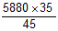
1
= 4573.3 (W)
this step without the previous steps stated gains 3 marks
1
% Eff. = 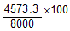
1
= 57.17 (%)
allow 57.17 with no working shown for 5 marks
1
(b) gpe = 600 × 9.8 × 35
1
= 205 800
1
gpe = KE = ½ m v²
1
v = 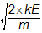
1
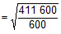
1
= 26.2 (m / s)
allow 26.2 with no working shown for 6 marks
1
[11]
Q5.(a) A
1
(b) C
1
(c) C
1
(d) B
1
(e) a series circuit has only one path/loop/branch
1
a parallel circuit has a branch(es) to provide more than one path / loop
allow answers that describe the difference in terms of potential difference, current or resistance
1
(f) R
1
(g) P
1
(h) Q = 0.97 × 60
1
Q = 58.2 (C)
1
Q = 58 (C)
an answer of 58 (C) scores 3 marks
1
[11]
Q6.(a) earth
1
(b) it can prevent an electric shock from the toaster
1
(c) 230 V
1
(d) (the potential difference) for the alternating supply changes direction
allow current
1
(the potential difference) for the alternating supply changes magnitude
allow current
allow converse
allow potential difference of alternating supply is greater
1
(e) there is an overall decrease
allow there is an decrease in percentage energy loss until 2013
1
but there is a (small) increase since 2013
1
(f) 1.92, 1.72, 1.70, 1.74, 1.77
1
(1.92 + 1.72 + 1.70 + 1.74 + 1.77)/5
1
1.77(%)
an answer of 1.77(%) scores 3 marks
1
[10]
Q7.(a) (i) (total) number of protons plus neutrons
accept number of nucleons
accept amount for number
do not accept number of particles in the nucleus
1
(ii) number of neutrons decreases by one
1
number of protons increases by one
accept for both marks a neutron changes into a proton
1
(b) (i) 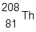
1
correct order only
1
(ii) the number of protons determines the element
accept atomic number for number of protons
1
alpha and beta decay produce different changes to the number of protons
there must be a comparison between alpha and beta which is more than a description of alpha and beta decay alone
or
alpha and beta decay produce different atomic numbers
ignore correct reference to mass number
1
[7]
Q8.(a) horizontal line drawn from
92 000 Bq
allow 90 000–94 000
1
1600 years
allow 1500–1700
1
(b) only (119) years have passed
1
activity has not dropped by much
1
(c)
Level 3: Relevant points (reasons/causes) are identified, given in detail and logically linked to form a clear account. | 5-6
Level 2: Relevant points (reasons/causes) are identified, and there are attempts at logically linking. The resulting account is not fully clear. | 3-4
Level 1: Points are identified and stated simply, but their relevance is not clear and there is no attempt at logical linking. | 1-2
No relevant content | 0
Indicative content
properties
• alpha is the least penetrating
• alpha is the most ionising
• alpha has least range in air
• beta is the second most penetrating
• beta is the second most ionising
• beta has the second longest range in air
• gamma is the most penetrating
• gamma is the least ionising
• gamma has the greatest range in air
hazard (linked to correct property)
• short-range alpha most dangerous
• mid-range beta most dangerous
• long range gamma most dangerous
6
[10]
Q9.(a) random
accept in all directions
1
description must be of random motion
(b) heating increases the temperature of the gas
1
temperature is proportional to kinetic energy
1
if kinetic energy increases speed increases
1
(c) energy is needed to change the state of the water
1
to break the bonds
1
(d) 1000 = m / 2.5 × 10⁻⁵
1
m = 2.5 × 10⁻⁵ × 1000
1
m = 0.025 (kg)
1
E = 0.025 × 2 260 000
1
E = 56 500 (J)
1
allow 56 500 (J) without working shown for 5 marks
0 marks awarded for E = m × L
(e) any four from:
• because the water is preheated) the change in temperature of the water
is less
• so less energy is used to heat the water (E=mcΔθ)
• therefore they (condensing boilers) are more efficient
• so less energy is wasted
• less gas is burned to heat the same amount of water
• less waste gas (CO₂) is produced by the boiler or (because less gas
is used) they are cheaper to run / save money
4
[15]
Q10.(a) (approximate same size particles as each other and as liquid and gas) touching
do not accept particles that overlap
1
regular arrangement (filling the square)
1
(b) condensing
1
(c) solid
1
(d) physical
1
(e) particles have more kinetic energy
1
particles move faster
1
(f) mass of the liquid
1
specific latent heat of vaporisation
1
(g) 2 × 4 200 × 80
1
672 000 (J)
an answer of 672 000 (J) scores 2 marks
1
[11]
Q11.(a) 17.8
accept 17.7 or 17.9
1
(b) potential difference = current × resistance
accept V = I R
1
(c) 3.22 = 2.18 × R
1
R = 3.22/2.18
1
R = 1.477(064...) Ω
1
R = 1.48 (Ω)
an answer of 1.48 (Ω) scores 4 marks
an answer that rounds to 1.48 (Ω) scores 3 marks
1
(d) temperature of wire will increase during experiment
allow description of this in terms of energy being dissipated, P = I²R
1
if constantan is used, this will not have a significant effect on results
1
(e) 50.0 cm
allow other ways of indicating the anomalous result in the table (eg ringing 5.26)
1
(f) the ammeter gave a reading that was too low
1
[10]
Q12.(a) gamma
allow 1 mark for 1 or 2 correct
beta
alpha
2
(b) any two from:
• do not point (radioactive) source at students
• keep (radioactive) source outside the box for minimum time necessary
• wear safety glasses or eye protection or do not look at source
• wear gloves
• hold (radioactive) source away from body
• hold (radioactive) source with tongs / forceps
2
(c) as time increases count rate decreases
1
count rate halves every 80 seconds
1
(d) half-life is 80 seconds
1
so after 200 seconds count rate = 113
1
(e) because a very small amount of radiation will be emitted or will be similar to / same as background radiation
1
[9]

